- Microsoft

AZURE
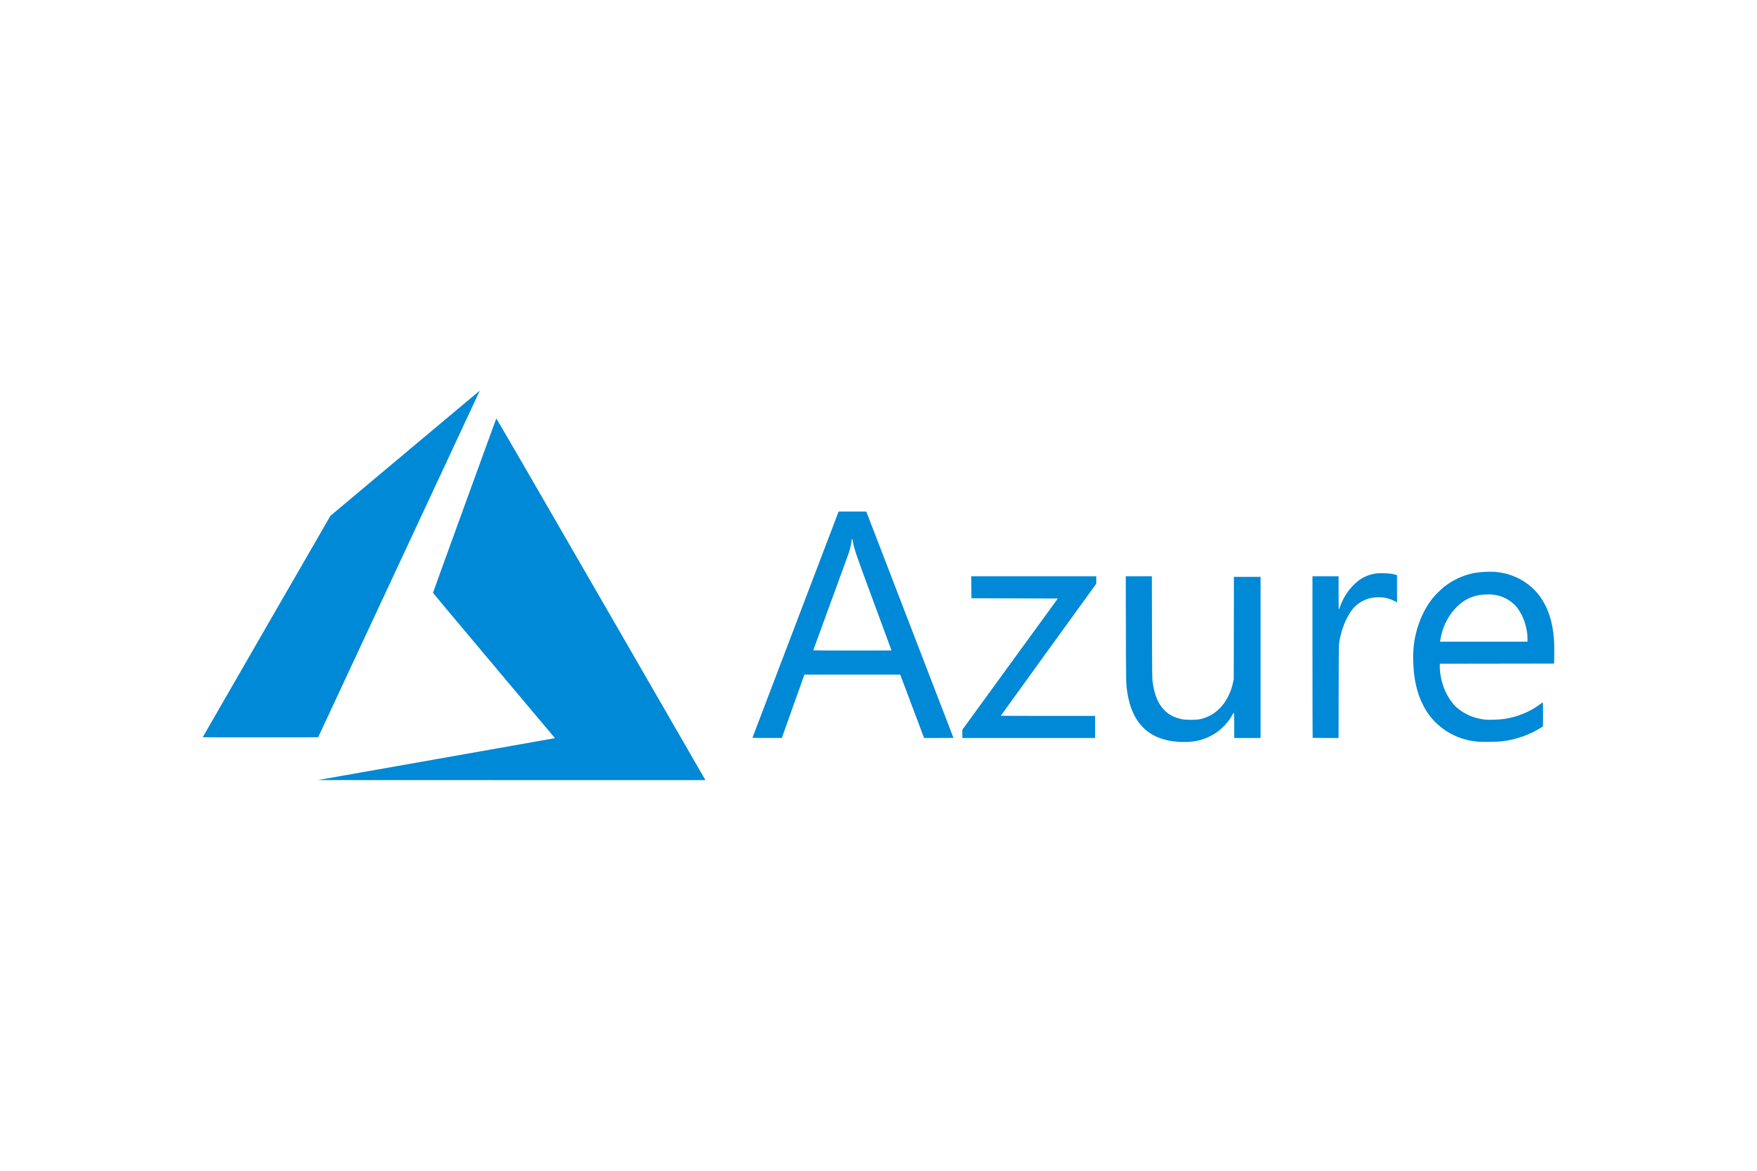

Cloud notes

- HOW TO CREATE AZURE ACCOUNT
Refer to Azure account create and practice Word or PDF

- RESOURCE GROUP

- A Resource Group is a logical container in the cloud that holds and organizes related resources like virtual machines, databases, storage accounts, and networks.
- It helps manage, monitor, and control resources as a single unit.
- You can apply permissions, policies, and billing to the whole group instead of individual resources.
  - Most commonly used in Microsoft Azure, but similar concepts exist in AWS and GCP (e.g., “Resource Tags” in AWS).

- Key Points:
- Logical grouping: Resources can be in the same group even if they are in different regions (depending on the cloud provider).
- Lifecycle management: Delete the resource group → all resources inside it are deleted.
- Access control: Apply role-based access to the whole group.

- Purpose of a Resource Group
- Organization: Groups all resources that share a common lifecycle (like an application, environment, or project).
- Management: You can deploy, monitor, and delete all the resources in a group together.
- Access control: You can assign role-based access control (RBAC) permissions at the resource group level.
- Cost tracking: Makes it easier to track costs for a specific project or environment.
- Automation: Templates (like ARM or Bicep templates) can deploy all resources in a group consistently.

Aspect | Pros | Cons
Organization | Logical grouping and clarity | Can become complex with many groups
Management | Easy to deploy/update/delete | Risk of accidental deletion
Access Control | RBAC simplifies permissioning | May not be granular enough
Cost Tracking | Easier to monitor costs | None significant
Automation | Works well with templates | Moving resources may break templates

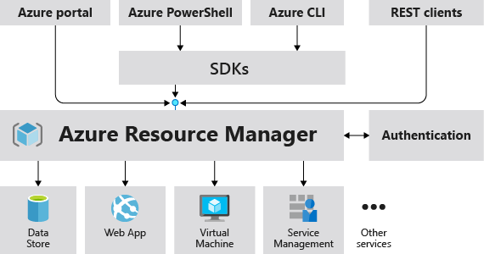

- Simplifies management: Easier to monitor, scale, and organize related resources.
- A resource group can contain any cloud resource that you deploy. Common categories include:
- Compute Resources : Resources used to run applications.
Examples: Virtual Machines (VMs), Containers / Kubernetes clusters, Serverless functions (Azure, Functions, AWS Lambda), App Services / App Engines

- Networking Resources : Resources that define the network topology.
Examples: Virtual Networks (VNet) / Virtual Private Cloud, VPCs, Subnets, Network Security Groups /, Firewall rules, Load Balancers, Public & Private IP addresses, VPN Gateways / ExpressRoute / Direct Connect

- Storage Resources : Data storage components.
Examples: Blob / Object Storage (Azure Blob, AWS S3, GCP Cloud Storage), Disks attached to VMs, File Shares / NAS, Backup Vaults, Storage accounts

- Database Resources : Managed database services.
Examples: SQL Databases (Azure SQL, RDS, Cloud SQL), NoSQL Databases (Cosmos DB, DynamoDB, Firestore), Managed Redis/Caching systems, Data warehouses (Synapse, Redshift, BigQuery)

- Security & Identity Resources : Security-related components.
Examples: Key Vaults / Secrets Manager, Certificates, IAM roles & policies, Security policies, Access control rules

- Monitoring & Management Resources : Resources that help with logs, metrics, and automation.
Examples: Monitoring dashboards, Log Analytics workspaces, Alerts & metrics, Automation scripts (Azure Automation, AWS SSM), Policy assignments, Resource locks

- Application Integration Services : Middleware and integration components.
Examples: API Gateways, Service Bus / Messaging queues (SQS, Pub/Sub), Event Grid / EventBridge, Workflow automation services (Logic Apps, Step Functions)

- AI / Analytics Resources : Data and intelligence resources.
Examples: Data Lakes, ML Workspaces, Stream processing (Kafka, Event Hub), Analytics clusters (Databricks, EMR)

- Important Note (Azure-Specific)
Azure has a strict resource group concept:
- A resource must belong to exactly one resource group.
- A resource group can contain multiple resource types.

- A resource group can contain :
- Compute resources
- Network resources
- Storage resources
- Databases
- Security resources
- Monitoring/logging resources
- Integration services
- Analytics & AI services
- Anything else you deploy in the cloud

- The common types of resource groups across major cloud platforms (Azure, AWS, GCP)
- Organizational / Environment-Based Resource Groups: Separate resources by lifecycle stages like Dev, QA, Staging, and Prod for better access control, billing, and deployment management.
- Application or Project-Based Resource Groups: Group resources per application/project (e.g., Web App, CRM) to simplify deployment, monitoring, and cost tracking.
- Service or Layer-Based Resource Groups: Organize by architecture layers (Network, Compute, Storage, Database) for clear functional separation.
- Department or Business Unit Resource Groups: Allocate resources by departments (Finance, HR, Marketing) for cost management and budgeting.
- Compliance or Security-Based Resource Groups: Group sensitive resources (HIPAA, PCI-DSS) to enforce strict security policies and controls.
- Geographic or Region-Based Resource Groups: Organize resources by region (US-East, Europe, APAC) for latency optimization and data residency compliance.

Cloud Provider Terminology Mapping
Cloud Provider | Concept of Resource Group | Notes
Azure | Resource Group | Native feature; core management boundary
AWS | Resource Tags, Resource Groups | Tag-based resource grouping
GCP | Projects, Folders | Projects act like resource groups

- Main types of resource groups (conceptually):
- Environment-based (Dev/Test/Prod)
- Application-based
- Service/layer-based
- Department/business-based
- Compliance/security-based
- Region-based

- BASIC NETWORKING
- Basic networking refers to the foundational concepts, devices, and rules that allow computers and other devices to communicate with each other.
- It is the “language” and “infrastructure” that enables data to travel from one point to another—whether across a room or across the world.
- A network is a group of devices (computers, phones, servers, routers, etc.) connected to share information and resources.

- Networking follows rules called protocols.
The most important is TCP/IP (Transmission Control Protocol / Internet Protocol).
- IP: Identifies a device (like a home address).
- TCP: Ensures reliable delivery of data.

- Common Networking Terms
- DNS: Converts website names into IP addresses.
- MAC Address: Unique hardware address of a network device.
- Bandwidth: Maximum data rate.
- Latency: Time it takes for data to travel.
- Subnetting: Dividing a network into smaller parts.

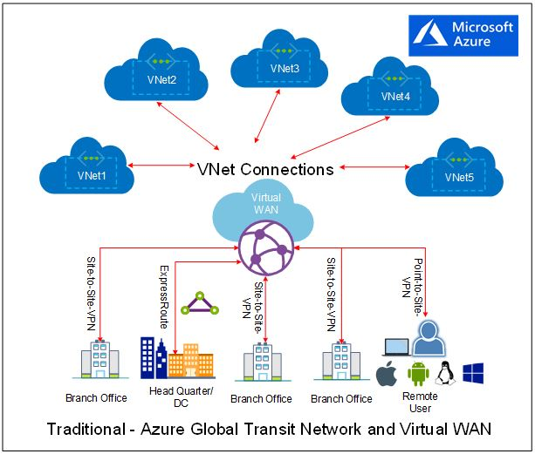
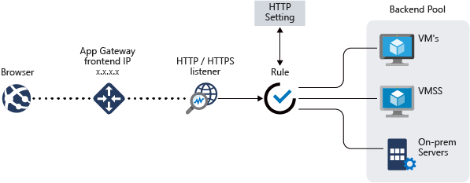

- Basic networking = Devices + Connections + Rules for communication.

  - IP ADDRESS
- An IP address (short for Internet Protocol address) is a unique numerical identifier assigned to each device that connects to a network (like the internet or a private LAN).
- An IP address identifies a device (such as a computer, phone, or server) on a network.
- It ensures that information sent over the internet (like emails, web pages, or files) reaches the correct destination.
- IP addresses are defined and managed by the Internet Protocol (IP) — a core communication protocol of the internet.
- It functions like a “home address” for your device allowing it to send and receive data across a network.

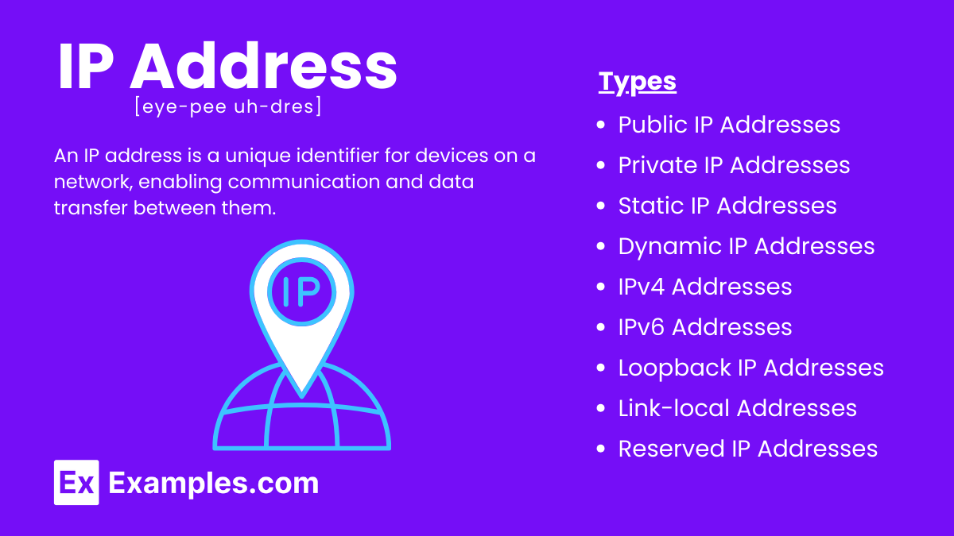

    - Structure of an IP Address
An IP address is made up of a series of numbers, separated by dots or colons, depending on the version.
There are two versions in use:
1. IPv4 (Internet Protocol version 4) | 2. IPv6 (Internet Protocol version 6)
Most common version (though slowly being replaced by IPv6). | Designed to replace IPv4 and provide many more addresses.
Uses 32 bits, written as four decimal numbers separated by dots. | Uses 128 bits, written as eight groups of hexadecimal numbers separated by colons.
Example: 192.168.1.10 | Example:  2001:0db8:85a3:0000:0000:8a2e:0370:7334
Each number can range from 0 to 255. | Abbreviations allowed (to simplify notation):  2001:db8:85a3::8a2e:370:7334
Total possible unique addresses:  2³² = ~4.3 billion addresses. | Total possible unique addresses:  2¹²⁸ ≈ 3.4 × 10³⁸ addresses — virtually unlimited.

Problem: The world ran out of IPv4 addresses due to the explosion of internet-connected devices.
IP address can not be defined ranges without CIDR as it divides it

- Types of IP Addresses
IP addresses can be categorized in multiple ways:

- Based on Scope
Type | Description | Example
Public IP Address | Used on the internet; globally unique; assigned by ISPs (Internet Service Providers). | 8.8.8.8 (Google DNS)
Private IP Address | Used within private networks (like home or office LANs); not routable on the internet. | 192.168.x.x, 10.x.x.x, 172.16.x.x – 172.31.x.x

Private IPs communicate inside the network;
A router translates them to a public IP using NAT (Network Address Translation) to access the internet.

- Based on Stability
Type | Description | Example Use
Static IP Address | Manually assigned, doesn’t change; ideal for servers, websites, or devices needing a consistent address. | Web servers, DNS servers
Dynamic IP Address | Automatically assigned by DHCP (Dynamic Host Configuration Protocol) and may change over time. | Home computers, mobile devices

    - What Is an IP Address Class?
- An IP address class is a way of categorizing IPv4 addresses based on how many network bits and host bits they contain.

- Each class defines:
- How many networks can exist.
- How many hosts (devices) each network can support.

- IP address classes are also called or known as Class full addressing
- IPv4 Address Basics
- IPv4 address = 32 bits (divided into 4 octets)
- Written as: X.X.X.X (e.g., 192.168.1.1)
- Each octet = 8 bits → value range 0–255
- The first few bits of the address determine the class.

- IP Address Classes and Their Ranges
Class | First Octet Range | Default Subnet Mask | Network / Host Distribution | Example Address | Usage
A | 1 – 126 | 255.0.0.0 (/8) | 8 bits for network, 24 for host | 10.0.0.1 | Very large networks (ISPs, big corps)
B | 128 – 191 | 255.255.0.0 (/16) | 16 bits for network, 16 for host | 172.16.5.4 | Medium networks (universities, enterprises)
C | 192 – 223 | 255.255.255.0 (/24) | 24 bits for network, 8 for host | 192.168.1.10 | Small networks (home, offices)
D | 224 – 239 | N/A | Used for multicasting | 224.0.0.1 | Group communication
E | 240 – 255 | N/A | Reserved for research and experimental use | 245.1.2.3 | Research only

Special Notes
- 127.x.x.x → Reserved for loopback (local testing).
Example: 127.0.0.1 = “localhost”
- 0.x.x.x → Represents “this network”
- 255.255.255.255 → Broadcast address

- Private IP Ranges by Class (RFC 1918)
Class | Private Range | CIDR Notation | # of IPs
A | 10.0.0.0 – 10.255.255.255 | 10.0.0.0/8 | 16,777,216
B | 172.16.0.0 – 172.31.255.255 | 172.16.0.0/12 | 1,048,576
C | 192.168.0.0 – 192.168.255.255 | 192.168.0.0/16 | 65,536

- Rest IP address not in of private are all public IP address

Quick Reference Summary
Class | Range (1st Octet) | Subnet Mask | Networks | Hosts per Network | Use Case
A | 1–126 | 255.0.0.0 | 128 | 16 million | Very large networks
B | 128–191 | 255.255.0.0 | 16,384 | 65,000 | Medium networks
C | 192–223 | 255.255.255.0 | 2 million | 254 | Small networks
D | 224–239 | N/A | N/A | N/A | Multicasting
E | 240–255 | N/A | N/A | N/A | Experimental

Some imp Points
- For changing Private to public or converting NAT is responsible
- Internet Service Provider is responsible public IP provider
- Private is used locally or internal hence it is used same IP at different places
- Because not exposed for public
- But public is different and unique

  - CIDR - CLASSLESS INTER-DOMAIN ROUTING
- CIDR stands for Classless Inter-Domain Routing.
- It’s a method used to allocate IP addresses and route IP packets more efficiently.
- CIDR replaced that with variable-length subnet masks, allowing networks to use exactly as many IP addresses as they need.

- IP address consists of 4 octets = 32 bits
- octet = 8 bits

- CIDR Notation
CIDR notation looks like this:
192.168.1.0/24
  - 192.168.1.0 → the network address
  - /24 → the prefix length, meaning the first 24 bits are the network part
  - the remaining (32 − 24 = 8) bits are for hosts.
So /24 corresponds to the subnet mask 255.255.255.0.

CIDR Notation | Subnet Mask | # of IP Addresses | Usable Hosts
10.0.0.0/8 | 255.0.0.0 | 16,777,216 | 16,777,214
172.16.0.0/16 | 255.255.0.0 | 65,536 | 65,534
192.168.1.0/24 | 255.255.255.0 | 256 | 254

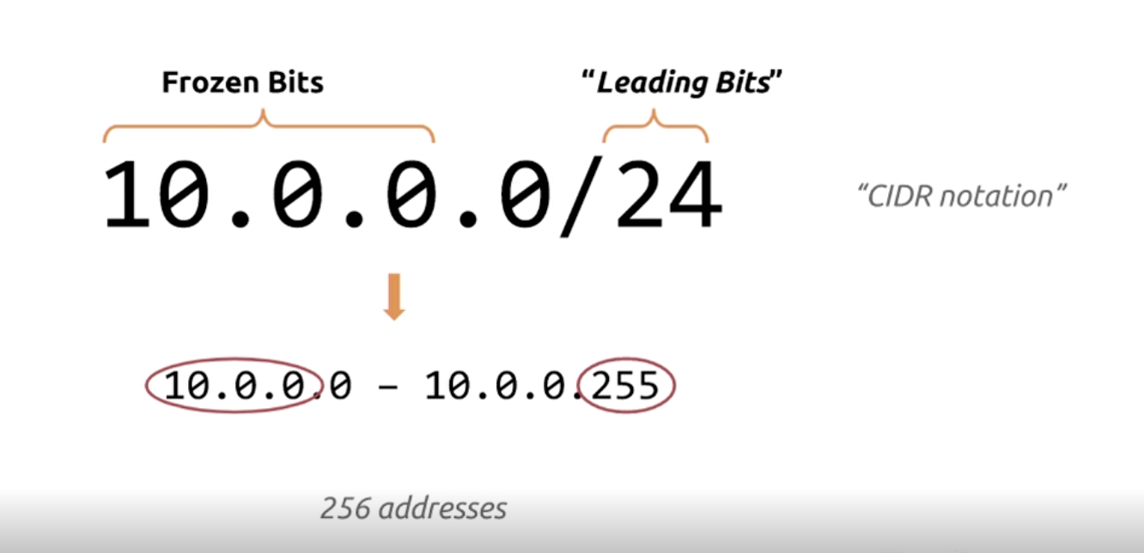

- Why CIDR Matters
- Makes IP address allocation more flexible
- Reduces waste of IPv4 addresses
- Improves routing efficiency by aggregating multiple routes (called route summarization or super netting)

- AZURE RESOURCE GROUP
- An Azure Resource Group (RG) is a logical container used to organize and manage Azure resources.
- Resources such as Virtual Machines, Storage Accounts, Virtual Networks, Databases, and App Services can be placed inside a Resource Group.
- Every Azure resource belongs to one and only one Resource Group.
- A Resource Group can contain resources from different Azure regions.

- Uses
- Resource Organization – Group resources belonging to the same application or project.
- Access Management – Apply Azure RBAC permissions at the Resource Group level.
- Resource Lifecycle Management – Delete a Resource Group to remove its resources together.
- Cost Management – Track and manage costs for resources in a project.
- Environment Management – Create separate RGs for Dev, Test, and Production.
- Automation – Manage resources using Terraform, ARM templates, Azure CLI, or PowerShell.

- Example :
Azure Subscription
│
└── RG: ecommerce-prod
│
├── Virtual Machine
├── Virtual Network
├── Load Balancer
├── Azure Database
└── Storage Account
- This keeps each environment separated and easier to manage.

Pros or Advantages | Cons or Disadvantages
Easy organization of Azure resources. | Deleting a Resource Group can delete all resources inside it.
Simplifies RBAC and permissions. | A resource can belong to only one Resource Group.
Makes resource deletion and lifecycle management easier. | Poorly designed RG structure can make large environments difficult to manage.
Useful for separating Dev/Test/Production environments. | Resource Groups are not a security boundary by themselves; proper RBAC, policies, and networking controls are still required.
Helps with cost tracking and management.
Works well with Infrastructure as Code tools such as Terraform.

- VNET – VIRTUAL NETWORK
- A VNet is a logically isolated cloud network where you can run your virtual machines (VMs), servers, databases, and apps securely.
- It allows your cloud resources to communicate with each other, the internet, or your on-premises network.

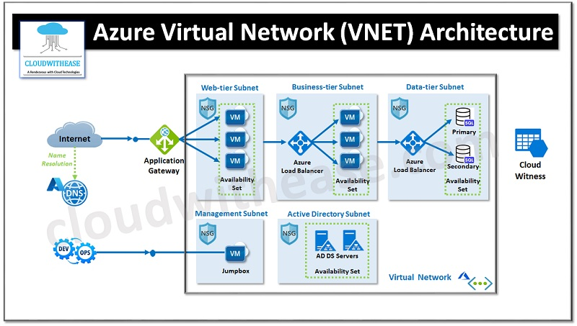

🔧 Key Features of a VNet
- Isolation : Each VNet is completely isolated from other VNets and customers.
No one can access it unless you allow them.

- Subnetting : ( In detail in 8.2 topic )
- You can divide a VNet into subnets, just like in traditional networking.
Example: VNet: 10.0.0.0/16
Subnets: 10.0.1.0/24 (web servers), 10.0.2.0/24 (database servers)
- This improves security and organization.

- Communication Options
- Resources inside a VNet can communicate through: Virtual Machines (VMs), App Services, Databases, Containers
- Communication can be: Within the same subnet, Across subnets, Between VNets, Between cloud and on-premises networks

- VNet Peering : Allows two VNets to connect privately without using the internet.
- Used when: Different departments have separate VNets,
You want them to communicate securely

- VPN Gateway / ExpressRoute : These services allow your on-premises office network to connect to your VNet.
- VPN Gateway : Secure encrypted tunnel over the internet.
- ExpressRoute : Private dedicated line (faster and more secure).

- Network Security :
- A VNet supports: Network Security Groups (NSGs) → control inbound/outbound traffic,
Firewalls, Route tables, DDoS protection

- What Can Be Hosted Inside a VNet?
- You can place almost any cloud resource inside a VNet:
- Virtual Machines, Databases (SQL Managed Instance), Containers (AKS), Application Gateways, Firewalls

- Importance of VNet
- Provides secure and isolated cloud networks
- Lets you control IP addressing, routing, traffic flow
- Enables hybrid networking with VPN/ExpressRoute
- Supports segmentation using subnets
- Works like a traditional physical network, but virtual

- A VNet is your private cloud network that you can divide into subnets, connect to your office, secure with firewalls, and use to run cloud servers safely.

- VNET – VIRTUAL NETWORK PEERING
- VNet Peering (Virtual Network Peering) is a powerful networking feature in Microsoft Azure
- Vnet peering allows to connects two or more Azure Virtual Networks (VNets) together, so that traffic between them is private and goes over the Azure backbone network, not the public internet.
- Allowing them to communicate with each other as if they were part of the same network.
- VNet peering connects two Azure VNets

- But for peering no subnets have repeating same private IP

- It is possible to make communication between same, different region and different subscription.
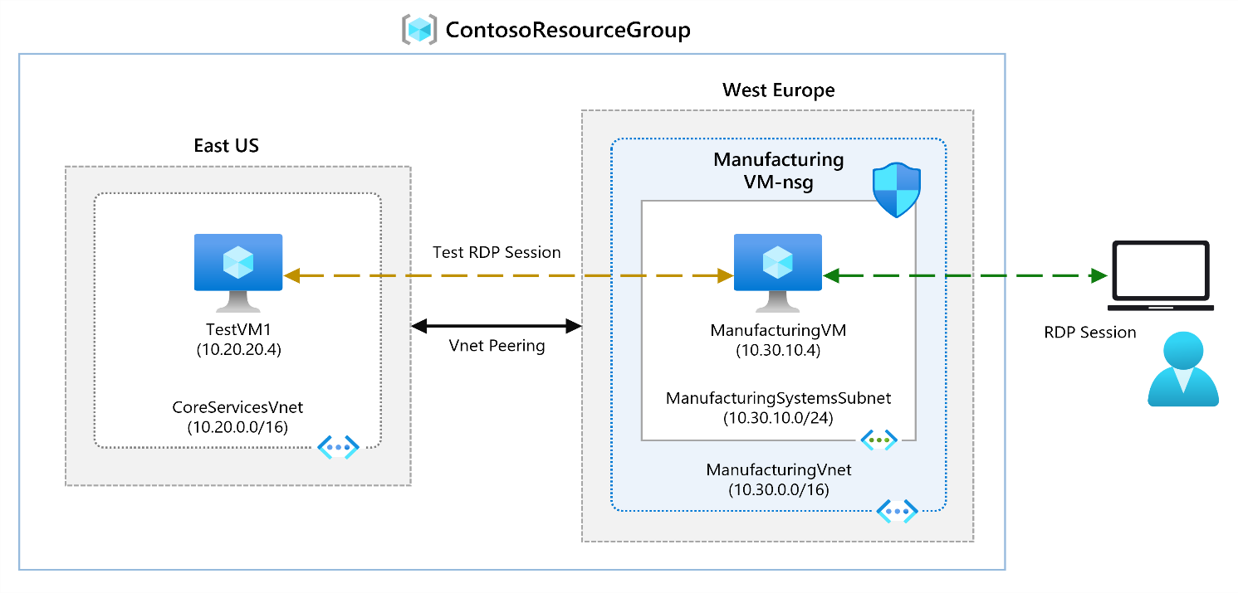
- Once Peering done
- Resources (like VMs, databases, etc.) in one VNet can communicate directly with resources in the other.
- The connection is low latency and high bandwidth.
- It’s secure, since it never leaves Azure’s internal network.

- Types of VNet Peering
There are two main types:
1. Intra-region VNet Peering (Regional Peering) | 2. Global VNet Peering
Connects VNets within the same Azure region. | Connects VNets across different Azure regions.
Example: VNet-A (East US) ↔ VNet-B (East US) | Example: VNet-A (East US) ↔ VNet-B (West Europe)
Use case: Connecting application and database subnets within the same region for better modularity. | Use case: Building a global network architecture for multinational workloads.

- How VNet Peering Works
- When you peer two VNets:
- Azure updates its routing tables automatically.
- Each VNet learns routes to the other’s address space.
- Communication between resources in both VNets happens via private IPs.
- No gateways, public IPs, or VPN tunnels are required.

- How to Configure VNet Peering : Step-by-step:
- In the Azure portal, open your first VNet.
- Under Settings → Peerings → Add.
- Choose:
- The remote VNet.
- Whether traffic forwarding or gateway transit is allowed.
- Create a reciprocal peering (unless you use “use remote gateway” options).

- You can also configure this with:
- Azure CLI, Azure PowerShell, ARM templates, Terra form

Important Peering Options
Option | Description | Example Use
Allow forwarded traffic | Allows traffic that is not from the local VNet (i.e., transit) | Needed for NVA or firewall scenarios
Allow gateway transit | Lets one VNet use another’s VPN gateway | Useful for hub-spoke networks
Use remote gateway | Allows peered VNet to use the gateway in another VNet | Common in hub-spoke topologies

- AVAILABILITY ZONE AND AVAILABILITY SET
- Both Availability Zones and Availability Sets are used to improve the availability and resiliency of applications, but they work differently.

- Availability Zone : An Availability Zone (AZ) is a physically separate location inside an Azure region.
  - Each zone has independent : Power, Cooling, Networking, Datacenter infrastructure

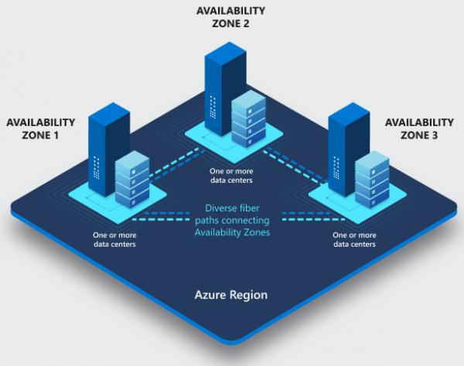
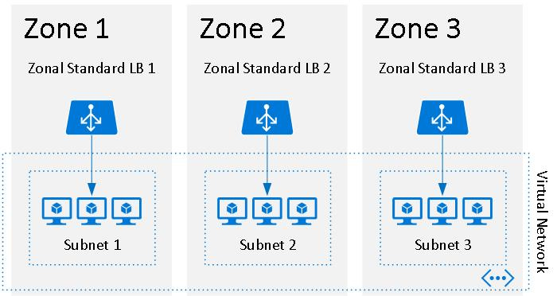
- Example: Suppose your application is deployed in East US:
Azure East US Region
│
┌───────────────┼───────────────┐
│ │ │
Zone 1 Zone 2 Zone 3
│ │ │
VM-1 VM-2 VM-3
│ │ │
└───────────────┴───────────────┘
Application

- If Zone 1 fails, VM-2 and VM-3 can continue serving the application.
- Use case: Production applications that require protection against datacenter/zone-level failures.

- Availability Set
- An Availability Set is a logical grouping of Azure VMs within a datacenter/region that distributes VMs across:
  - Fault Domains → separate physical hardware/rack infrastructure
  - Update Domains → separate maintenance groups
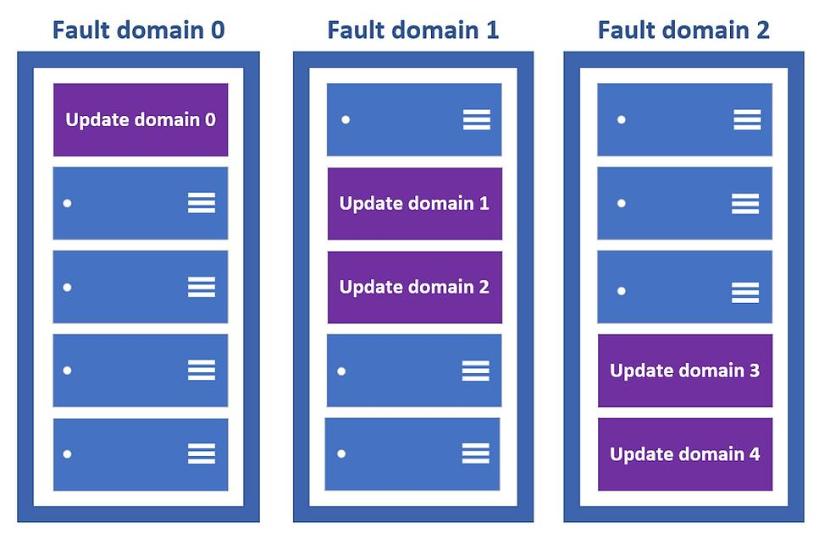
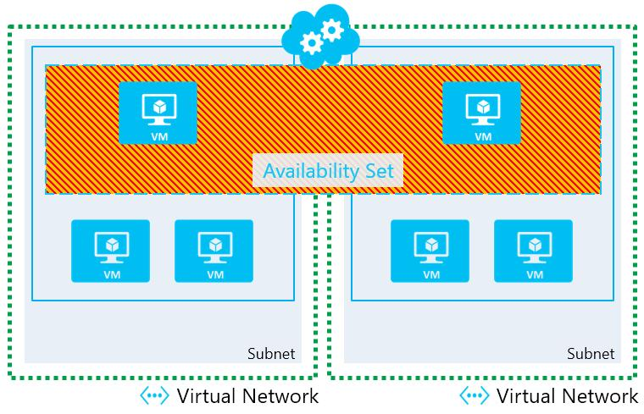

- Example:
- Suppose you have two web servers:
Availability Set
│
┌────────┴────────┐
│ │
Fault Domain 1 Fault Domain 2
│ │
VM-1 VM-2
│ │
└────────┬────────┘
│
Load Balancer

- If the hardware hosting VM-1 fails, VM-2 can continue running.
- During planned maintenance, Azure can also place VMs in different Update Domains, so it doesn't restart all VMs at the same time.

- Main Difference
Feature | Availability Zone | Availability Set
Scope | Separate physical zones | Logical VM grouping
Protects against | Zone/datacenter failure | Hardware/maintenance failure
Infrastructure | Separate datacenters within region | Shared regional datacenter infrastructure
Uses | Zones | Fault + Update Domains
Best for | Higher availability | Basic VM redundancy
Example | VM in Zone 1 + VM in Zone 2 | VM-1 + VM-2 in one Availability Set

- Availability Zone = Separate buildings
- Availability Set = Separate racks/hardware groups within the infrastructure

For example, for a production web application, you could deploy:
Azure Region
│
┌──────────┴──────────┐
│ │
Zone 1 Zone 2
│ │
Web VM 1 Web VM 2
│ │
└──────────┬──────────┘
│
Load Balancer
│
Users
- This provides stronger protection than putting both VMs only in an Availability Set.

- NSG – NETWORK SECURITY GROUP
- A Network Security Group (NSG) is a fundamental cloud networking component that acts as a virtual firewall for your cloud resources.
- It contains a list of security rules that allow or deny traffic based on : Source/Destination IP address, Port number, Protocol (TCP, UDP, ICMP), Direction (Inbound/Outbound)
- Control inbound and outbound network traffic to Azure resources such as : Virtual Machines, (VMs), Subnet within Virtual Networks (VNets), Network interfaces (NICs)

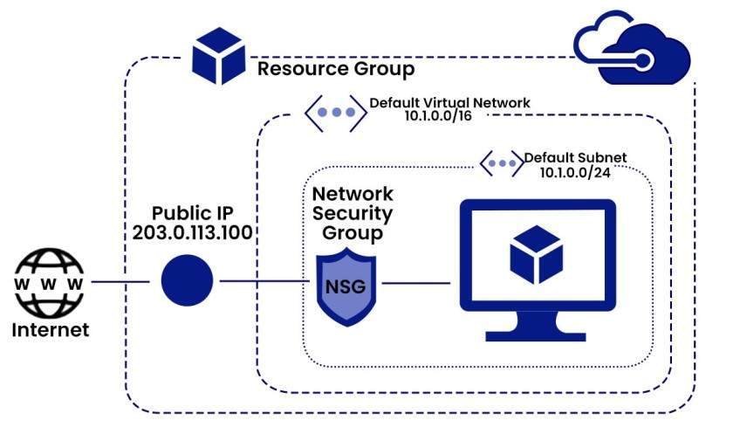

- How It Works : Each rule in an NSG has:
- Name – Unique identifier for the rule
- Priority – Determines rule order (lower number= higher priority, Higher number=Lower Priority )
- Source/Destination – IP address or tag (e.g., Internet, VirtualNetwork)
- Port – Specific port(s) (e.g., 80 for HTTP, 22 for SSH, 3389 for Windows )

- Protocol – TCP, UDP, or Any
- Action – Allow or Deny
- Direction – Inbound or Outbound

- When traffic reaches a resource, Azure checks the NSG rules in order of priority to decide whether to allow or deny it.

- Types by Functionality & Rule Components
Regardless of the provider, all NSGs are built from the same fundamental types of rules and concepts.

- Inbound and Outbound Rules
- Inbound Rules: Control traffic coming into a resource from an external source.
For example, "Allow traffic on port 443 (HTTPS) from any IP address."

- Outbound Rules: Control traffic going out from a resource to a destination.
For example, "Deny all traffic from the virtual machine to the internet."

- Stateful and Stateless
- This is a critical concept that defines how the firewall handles return traffic.
- Stateful (Most Common): This is the default for Azure NSGs, AWS Security Groups, and GCP Firewall Rules.
If you allow an inbound request, the firewall automatically tracks the connection and allows the corresponding outbound response without needing a specific outbound rule.
- Example: If you allow inbound SSH (port 22), you don't need to create an outbound rule to allow the server's reply on that connection.

- Stateless: The firewall treats each packet individually and has no memory of past connections. You must explicitly create rules for both directions of a conversation.
Example: AWS Network ACLs (NACLs) are stateless. If you allow inbound port 80, you must also create a separate rule to allow outbound traffic on the ephemeral ports for the response.

- Allow and Deny Rules : The action a rule takes when traffic matches its criteria.
- Allow Rules: Explicitly permit traffic that matches the rule.
- Deny Rules: Explicitly block traffic that matches the rule.
- Implicit Deny: All NSGs have a final, unwritten rule that denies all traffic that wasn't explicitly allowed by an earlier rule.
This is the foundation of the "default deny" security posture.
Interpretation 3: Types by Service Tier (Provider-Specific)
Some providers offer different tiers or versions of their NSG service with varying features. Azure is the best example of this.

- Azure NSG SKUs (Stock Keeping Units)
Feature | Basic SKU | Standard SKU
Scope | Regional only. | Regional, but can be used with features like Service Endpoints.
IP Address Ranges | Limited. | Supports a much larger number of IP address ranges per rule.
Service Tags | No. | Yes. Allows you to allow/deny traffic to entire Azure services (e.g., Storage.WestUS).
Enhanced Logging | Basic flow logs. | Yes. Supports Network Watcher flow logs and more detailed diagnostics.
Availability Zones | Not supported. | Yes. Can be zonal for higher resilience.
Recommendation | Good for simple, non-critical workloads. | Recommended for all production workloads due to its enhanced features and security capabilities.

- Types of NSG Level Usage in the Cloud
Different levels or scopes where they are applied. As deployment types or scopes:
Type / Scope | Description | Typical Use Case
Subnet-level NSG | Applied to an entire subnet. Affects all resources (VMs, NICs) in that subnet. | Use when you want uniform security rules for all resources in a subnet (e.g., block external traffic except via a load balancer).
NIC-level NSG (VM-level) | Applied directly to a network interface (NIC) of a VM. | Use when you need fine-grained control (e.g., one VM in a subnet should allow RDP, others shouldn’t).

- Where NSGs Are Applied
- Subnet level: Controls traffic for all resources in the subnet
- Network Interface level (NIC): Controls traffic for a specific VM
- If both are applied, rules are combined, with the most restrictive rule taking effect.

- NSG (Network Security Group) types in cloud
- Internet-Facing Security (Front Door)
- Protect public servers like web servers.
- Allow: HTTP (80), HTTPS (443).
- Deny: Everything else (RDP, SSH, DB ports).

- Internal Network Segmentation (Internal Walls)
- Separate web, app, and database tiers for safety.
- Web Subnet: Allow internet → Web; Web → App.
- App Subnet: Allow Web → App; App → DB.
- DB Subnet: Allow App → DB only. Deny internet access.

- Secure Management Access (Service Entrance)
- Don’t open RDP/SSH to the internet.
- Use a Bastion Host (Jump Box) in a secure subnet.
- Only allow management from trusted IPs.

- Control Outbound Traffic (Outbound Flow)
- Limit what servers can send out.
- DB Servers: Block all internet access.
- Web Servers: Allow only needed APIs or services.
- Use Service Tags (like AzureKeyVault) to simplify rules.

- Secure Hybrid Connections (Bridge)
- Protect cloud–on-premises links (VPN or ExpressRoute).
- Allow only specific on-prem systems to reach cloud resources.

  - NSG IN NIC LEVEL
Network Security Group in Network Interface Card Level

- NIC stands for Network Interface Card = Network Adapter = Network Interface Controller
- It is a hardware component that allows a computer or device to connect to a network, such as a Local Area Network (LAN) or the Internet.
- The NIC provides the physical interface (port) and manages the low-level communication with the network (sending and receiving data packets).

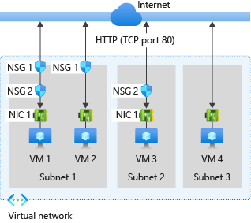

- Functions of NIC
- Connects the device to a wired or wireless network.
- Converts data from the computer into a form suitable for transmission over the network.
- Handles addressing (MAC address) and data framing.
- Controls data transmission speed and error detection.

- Types of Network Interface Cards:
- Based on Network Type
- Ethernet NIC: For wired LAN (RJ-45 connector).
- Wireless NIC: Connects via Wi-Fi.
- Fiber Optic NIC: High-speed, long-distance connection.
- Bluetooth NIC: For short-range wireless communication.

- Based on Bus Interface
- PCI / PCIe NIC: Internal cards installed on the motherboard.
- USB NIC: External, connects via USB port.

- Based on Speed
- Fast Ethernet: Up to 100 Mbps
- Gigabit Ethernet: Up to 1 Gbps
- 10G/25G/100G NICs: For high-performance networks.

- Based on Functionality
Dedicated NIC: Separate hardware card.
Integrated NIC: Built into the motherboard.
Virtual NIC (vNIC): Software-based for virtual machines.

- Types of NICs in Cloud
- Primary NIC
- The default network interface attached to a VM when it’s created.
- Used for the main IP address and default network traffic.
- Required for all instances.

- Secondary NIC
- Additional network interfaces attached to a VM for segregated network traffic.
- Used for multi-network setups (e.g., internal + external networks).

- Public (External) NIC
- Connects the instance to the internet or external networks.
- Typically assigned a public IP.

- Private (Internal) NIC
- Connects the instance to private subnets or internal networks.
- Used for internal communication between servers, databases, or microservices.
- Does not have a public IP.

- Accelerated / Enhanced NIC
- A high-performance network interface designed for low latency and high throughput.
- Used in workloads like high-performance computing (HPC), AI, or big data.

- Virtual Function (VF) NIC
- A virtualized interface created using SR-IOV (Single Root I/O Virtualization).
- Allows multiple VMs to share a single physical NIC efficiently while maintaining high performance.
- Common in high-speed network environments.

Type | Purpose | Example Use Case
Primary NIC | Default network connection | Basic VM networking
Secondary NIC | Additional network interfaces | Multi-network connectivity
Public NIC | Internet access | Web servers
Private NIC | Internal communication | Databases, app backends
Accelerated NIC | High-performance networking | AI, HPC workloads
Virtual Function NIC | SR-IOV-based performance | Virtualized environments

  - NSG IN SUBNET LEVEL
Network Security Group in Sub Net Level

- NSG – Network Security Group
- In cloud is a virtual firewall that controls inbound and outbound traffic to resources using security rules.
- It helps protect VMs and subnets by allowing or denying network traffic based on defined policies.

- VNet – Virtual Network : It is a private, isolated network in the cloud that allows cloud resources to communicate securely with each other.
- It provides IP addressing, subnets, routing, and security controls similar to an on-premise network.

- Subnet in Cloud :
- A subnet (sub-network) is a logical subdivision of a virtual network (VNet/VPC) in cloud computing.
- Cloud providers (AWS, Azure, GCP) let you take a large IP address range (like 10.0.0.0/16) and divide it into smaller networks—for example, 10.0.1.0/24, 10.0.2.0/24.
- It helps in organizing and isolating cloud resources.

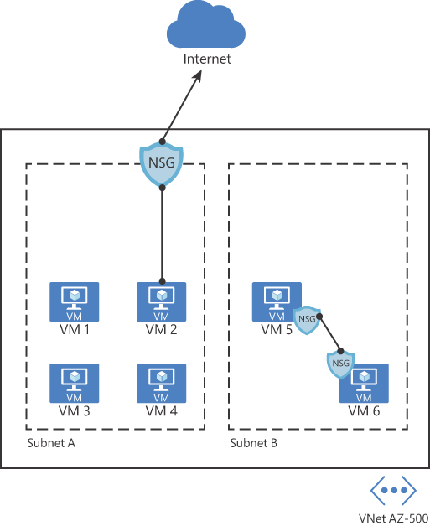

- A subnet contains:
- A range of private IP addresses
- Network routing rules
- Security controls
- Specific network characteristics (private/public)

- Purpose of Subnets
- Segmentation of resources : Helps group resources based on function:
- Web servers in one subnet
- App servers in another
- Database servers in another

- Security and isolation : You can apply different firewalls, route tables, or access rules for each subnet.

- Efficient IP management : Breaking a large network into smaller parts.

- High availability : Cloud requires multiple subnets in different availability zones.

- Types of Subnets in Cloud
- Public Subnet :
- Has a route to the internet
- Used for resources like web servers, bastion hosts

- Private Subnet
- No direct internet access
- Used for databases, internal apps

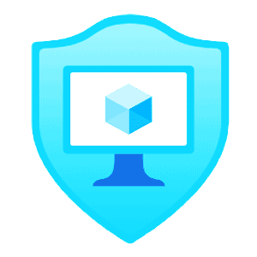
- ASG – APPLICATION SECURITY GROUP
- An Application Security Group is a logical group of NICs (Network Interface Card ) attached to VMs.
- An Application Security Group (ASG) is a cloud networking feature that lets you logically group virtual machines (VMs) and apply security rules based on the application role, instead of using IP addresses or subnets.
- It makes network security easier, cleaner, and scalable.
- You can then use ASGs inside Network Security Group (NSG) rules to define which VM groups can talk to each other.

- Instead of using IPs → you use groups
- Instead of managing VM-by-VM rules → you manage application-level groups

- ASG works with in a Vnet only
- If Virtual Machine or subnet is in different Vnet you cannot apply NSG

- Why ASGs were created
- Modern cloud applications often have: Web tier, Application tier, Database tier

- Traditionally you would write many security rules using IP address ranges, which is error-prone and hard to maintain.

- ASGs allow you to put each tier into a logical group, then create rules that say:
- “Web servers can talk to App servers on port 8080”
- “App servers can talk to Database servers on port 1433”
With no IP management required.

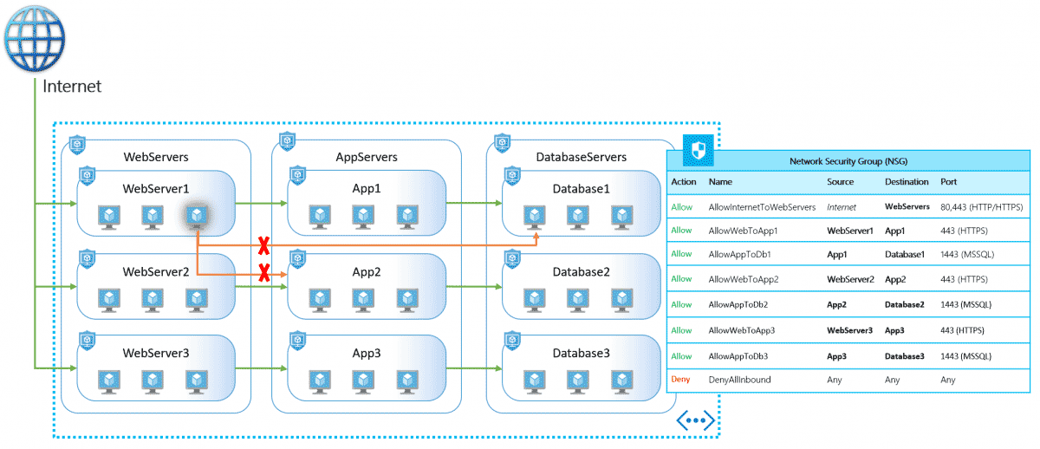

- ASGs Work (Step-by-Step)
- Create ASGs
Examples: ASG-Web, ASG-App, ASG-DB

- Assign VMs’ NICs to an ASG
Each VM becomes part of the group (e.g., all web VMs → ASG-Web).

- Create NSG (Network Security Group) rules using ASGs:
For example: Source ASG: ASG-Web, Destination ASG: ASG-App, Port: 8080, Action: Allow

- Attach NSG to ASG tier ( Web, App or DB) : Traffic is filtered according to these rules.

Example Architecture with ASGs
Tier | ASG Name | Rules
Web Servers | ASG-Web | Can receive HTTPS from Internet
App Servers | ASG-App | Accepts traffic only from ASG-Web
Database Servers | ASG-DB | Accepts SQL traffic only from ASG-App

No IP addresses are needed in security rules.

- Benefits of ASGs
- Simplified Security Management : Instead of updating IP addresses every time you add/remove a VM, just keep it in an ASG.
- Scale Easily : When you scale VM instances (e.g., auto-scaling), they automatically inherit the security rules through their ASG.
- Least Privilege Access : You define communication at the application role level, enforcing proper segmentation.
- Cleaner, Readable Network Rules
- Security rules become understandable: “Web → App on port 8080”, “App → DB on port 1433”
- Much clearer than: “10.0.4.5/32 → 10.0.6.7/32”

- ASG vs NSG
Feature | NSG | ASG
Purpose | Firewall rule set | Group of VMs used inside NSG rules
Controls traffic? | Yes | No (they’re used by NSGs)
Applied to | Subnets / NICs | NICs only
Works with IPs | Yes | No, only groups

- Simple
- NSG = Security rules
- ASG = Who the rules apply to

- AZURE LOAD BALANCER

- An Azure Load Balancer is a high-performance Layer 4 (TCP/UDP) load balancing service provided by Microsoft Azure.
- It automatically distributes incoming network traffic across multiple virtual machines (VMs) or resources in order to ensure high availability, scalability, and reliability of your applications.

- The Azure Load Balancer acts as a traffic distributor.
- It ensures that requests from users are evenly spread across backend resources (like VMs) so that no single instance is overloaded.
- It distributes load globally and regional.
- It works as a proxy-based routing.
It is a routing method where an intermediate server (proxy) receives client requests, decides where to send them, and forwards the request to the appropriate backend server.

- It works at Layer 4 (Transport Layer) of the OSI model, meaning it routes traffic based on:
  - Source IP,
  - Destination IP,
  - Port numbers (TCP/UDP)
- It sends request to backend pool using round robin method.
- Round Robin is a CPU scheduling method where each process gets an equal, fixed time slice in cyclic order. It ensures fairness by repeatedly rotating through all processes until they finish.

It does not inspect the data inside packets (unlike Application Gateways, which work at Layer 7).

- Key Features
Feature | Description
High Availability | If one VM becomes unhealthy, traffic is automatically rerouted to healthy VMs.
Scalability | Supports millions of flows and scales automatically as load increases.
Inbound and Outbound Rules | Can manage both inbound (user-to-service) and outbound (service-to-internet) connections.
Health Probes | Continuously checks the status of backend VMs to detect failures.
NAT Rules | Provides inbound NAT (Network Address Translation) for direct VM access via specific ports.
Public & Internal Options | Can balance traffic from the internet (Public) or within a virtual network (Internal).

- Types of Azure Load Balancers
Type | Description | Use Case
Public Load Balancer | Has a public IP address and distributes internet traffic to backend VMs. | Web applications, APIs accessible from the internet.
Internal Load Balancer (ILB) | Has a private IP within a Virtual Network (VNet) and handles internal traffic. | Database servers, internal apps, microservices within Azure.

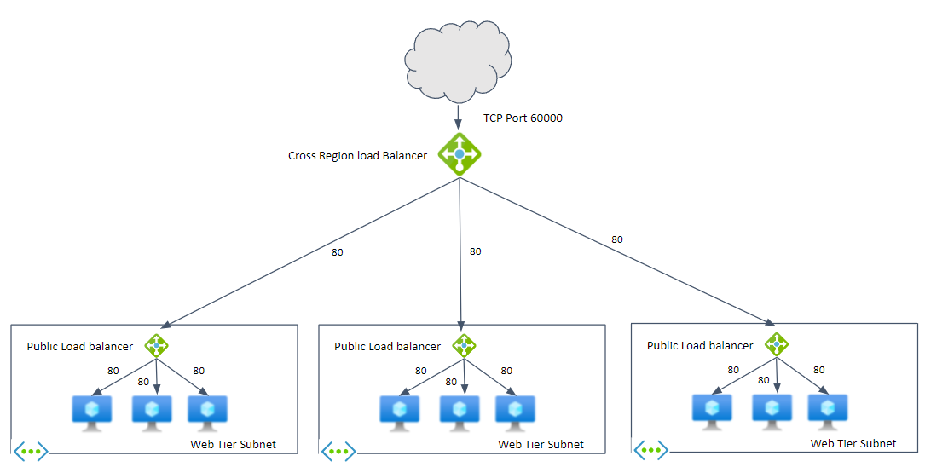

- Health Probes
- Health probes are used to check the availability of each backend instance.
  - Protocol: HTTP, HTTPS, or TCP
  - Frequency: Configurable (e.g., every 5 seconds)

- If a VM fails the probe (no response),
- The Load Balancer stops sending traffic to it until it becomes healthy again.

- How Azure Load Balancer Works
Example: Public Load Balancer for a Web App
- A client sends a request to the app’s public IP.
- The Load Balancer:
  - Checks its load-balancing rules.
  - Runs health probes to see which VMs are healthy.
  - Routes traffic to a healthy backend VM using a distribution algorithm (e.g., hash-based).
- The VM processes the request and responds to the client via the Load Balancer.

- Components
Component | Description
Frontend IP Configuration | The IP address clients use to access the service.
Backend Pool | Group of VMs or instances that receive traffic.
Load Balancing Rules | Define how traffic maps from frontend to backend (ports, protocols, etc.).
Health Probe | Monitors VM health.
Inbound NAT Rules | For direct access to individual VMs (e.g., SSH or RDP).

- Common Use Cases
- Web Applications: Distribute traffic across multiple web servers.
- High Availability Clusters: Ensure redundancy — if one VM fails, another takes over.
- Internal Load Balancing: Distribute internal service traffic between VMs (e.g., app servers to database tier).
- Outbound Connections: Allow VMs in a private network to access the internet using a shared public IP.

- Security and Integration
- Integrated with Network Security Groups (NSGs) for traffic filtering.
- Works with Azure Virtual Network (VNet) for isolation.
- Can be combined with Azure Application Gateway (Layer 7) for advanced routing (SSL termination, URL path-based routing, etc.).

- Example Scenario
- Goal: Deploy a web app across 3 VMs behind a Load Balancer.
- Steps:
  - Create a Public Load Balancer with a public IP.
  - Add your VMs to the backend pool.
  - Create an HTTP health probe (e.g., /health).
  - Set up a Load Balancing Rule:
    - Frontend Port: 80
    - Backend Port: 80
  - Protocol: TCP
  - Configure NSG rules to allow inbound HTTP traffic.
  - Test by accessing the Load Balancer’s public IP — requests are distributed among all 3 VMs.

- AZURE APPLICATION GATEWAY
- An Azure Application Gateway is an Application Layer (Layer 7) load balancer and web traffic manager provided by Microsoft Azure.
- The Azure Application Gateway manages and distributes web traffic (HTTP and HTTPS) to backend resources like virtual machines (VMs), virtual machine scale sets, app services, or containers.

- It is regional load balancer only.
- It should have dedicated subnet.

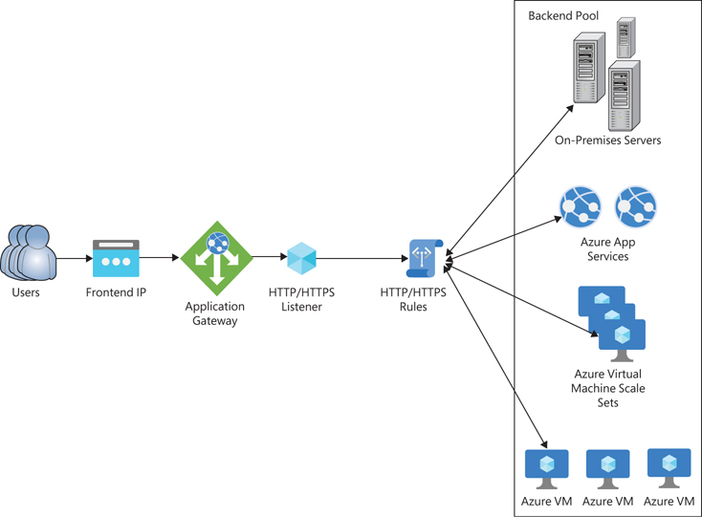

- Unlike the Azure Load Balancer, which operates at the Transport Layer (Layer 4), the Application Gateway can inspect HTTP(S) requests, make intelligent routing decisions, and offer advanced web application delivery features such as SSL termination, URL-based routing, path based routing and Web Application Firewall (WAF).

- It doesn’t just balance network connections — it understands web traffic.
- This means it can make content-based routing decisions, like:
  - Sending /images requests to one server pool
  - Sending /api requests to another pool

- Key Features
Feature | Description
Layer 7 Load Balancing | Routes traffic based on HTTP request properties such as URL path or host headers.
Web Application Firewall (WAF) | Protects web apps from common attacks like SQL injection, XSS, and OWASP Top 10 vulnerabilities.
SSL Termination | Decrypts HTTPS traffic at the gateway level, reducing CPU load on backend servers.
URL-Based Routing | Routes different URLs to different backend pools. Example: /api → API servers, /images → image servers.
Multi-Site Hosting | Host multiple websites using a single Application Gateway (based on host headers).
Session Affinity (Cookie-Based) | Ensures a user’s session stays on the same backend instance (useful for shopping carts, login sessions).
Autoscaling | Automatically adjusts capacity based on incoming traffic.
Custom Error Pages & Redirects | Customize HTTP error responses or perform HTTP to HTTPS redirection.
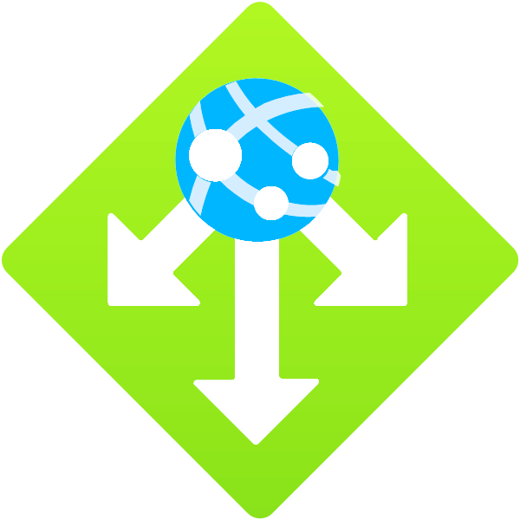
- How It Works
- When a user sends an HTTP/HTTPS request:
- The request reaches the Application Gateway’s frontend IP (public or private).
- The listener on the gateway receives the request.
- Based on rules, host name, or URL path, the gateway decides which backend pool should handle the request.
- Before sending traffic, it may:
  - Decrypt HTTPS traffic (if SSL termination is enabled)
  - Inspect traffic for security threats (if WAF is enabled)
- The request is then sent to a healthy backend server.
- The backend response is returned through the same gateway to the client.

- Components of Application Gateway
Component | Description
Frontend IP Configuration | The IP address exposed to clients (can be public or private).
Listener | Listens for incoming HTTP/HTTPS requests using a specific port, protocol, and host name.
Rules | Define how requests are routed based on conditions (path-based or host-based routing).
Backend Pool | Group of backend servers or services that handle requests.
Health Probes | Continuously check backend health. Unhealthy instances stop receiving traffic.
Web Application Firewall (WAF) | Filters and protects traffic using security rules.

- Deployment Modes
Mode | Description | Use Case
Standard (Load Balancer) | Provides Layer 7 routing, SSL offloading, and session affinity. | Basic web apps needing intelligent routing.
WAF (Web Application Firewall) | Adds WAF protection on top of the Standard features. | Internet-facing web apps needing security against attacks.

- Health Probes
- A health probe in Azure is a periodic check used by load balancers to determine whether an application endpoint is healthy and able to receive traffic.
- If a probe fails repeatedly, Azure stops sending traffic to that instance until it becomes healthy again.

- Web Application Firewall (WAF)
- A Web Application Firewall (WAF) in Azure protects web apps from common threats like SQL injection, XSS, and other OWASP top-10 attacks.
- It filters, monitors, and blocks malicious HTTP/S traffic before it reaches your application.

You can run it in:
- Detection mode (logs attacks but doesn’t block)
- Prevention mode (actively blocks malicious requests)

    - Common Use Cases
Use Case | Description
Multi-site Hosting | Host multiple domains on one gateway (e.g., app1.contoso.com, app2.contoso.com).
Microservices Routing | Route based on URL paths to different backend services.
SSL Offloading | Terminate SSL/TLS at the gateway instead of backend VMs.
Web App Protection (WAF) | Defend web apps from vulnerabilities and attacks.
Autoscaling Web Frontend | Automatically scale capacity to meet demand.

    - Application Gateway vs Azure Load Balancer
Feature | Azure Load Balancer | Azure Application Gateway
OSI Layer | Layer 4 (Transport) | Layer 7 (Application)
Traffic Type | TCP/UDP | HTTP/HTTPS
Routing Basis | IP/Port | URL/Host/Header
SSL Termination | ❌ No | ✅ Yes
WAF (Security) | ❌ No | ✅ Yes
Session Affinity | Basic (by IP) | Cookie-based
Use Case | General-purpose traffic distribution | Web application routing and security


- TRAFFIC MANAGER
    - Azure Traffic Manager is a DNS-based traffic load balancer that helps you distribute network traffic across multiple endpoints (such as Azure VMs, web apps, or external websites) in different regions to improve performance, availability, and resiliency of your applications.

    - What Traffic Manager Does
- Traffic Manager directs client requests to the most appropriate endpoint based on a traffic-routing method that you define.
- It doesn’t directly handle the traffic—it just tells clients (via DNS responses) which endpoint they should connect to.

    - How It Works
- A user tries to reach your application (e.g., myapp.contoso.com).
- The user’s DNS resolver queries Traffic Manager for the best endpoint.
- Traffic Manager applies your configured routing policy.
- It returns the DNS name of the selected endpoint.
- The user’s request then goes directly to that endpoint — Traffic Manager doesn’t proxy or inspect traffic.

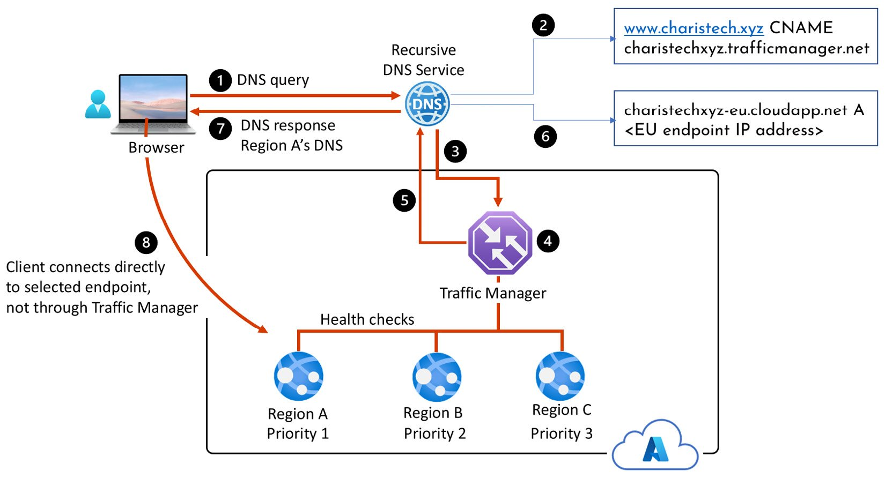

    - Routing Methods (Policies)
Routing Method | Purpose
Priority | Route all traffic to a primary endpoint; use backups if it’s unhealthy. Ideal for failover.
Weighted | Distribute traffic across endpoints based on assigned weights (e.g., 70/30 split).
Performance | Send users to the endpoint with the lowest network latency based on geographic location.
Geographic | Direct users based on the region they’re connecting from (useful for compliance or localization).
Multivalue | Return multiple healthy endpoints for clients to choose from (useful for client-side load balancing).
Subnet | Route traffic based on the client’s IP address range (useful for internal routing or special user groups).

    - Health Monitoring
- Traffic Manager regularly probes endpoints (via HTTP/HTTPS/TCP) to check availability.
- If an endpoint becomes unhealthy, Traffic Manager automatically stops directing traffic to it.

    - Common Use Cases
- Global load balancing between data centers or regions.
- Failover between primary and secondary sites.
- Geolocation-based routing for data sovereignty or localization.
- Smooth migration between deployments or clouds (Azure, AWS, on-prem, etc.).

- DNS is mandatory to route.
- Traffic Manager it provides and works with domain name instead of an IP address

- APP OR APPLICATION SERVICE
    - Azure App Service is a fully managed Platform as a Service (PaaS) offering from Microsoft Azure that enables you to build, host, and scale web applications, REST APIs, and mobile backends — without managing infrastructure.
- Azure App Service allows developers to deploy web applications quickly using a variety of programming languages and frameworks (like .NET, Java, Node.js, Python, PHP, and Ruby), while Azure automatically handles:
- Server provisioning
- Load balancing
- Auto-scaling
- Patch management
- Continuous deployment
This means you focus on writing code, not managing servers.

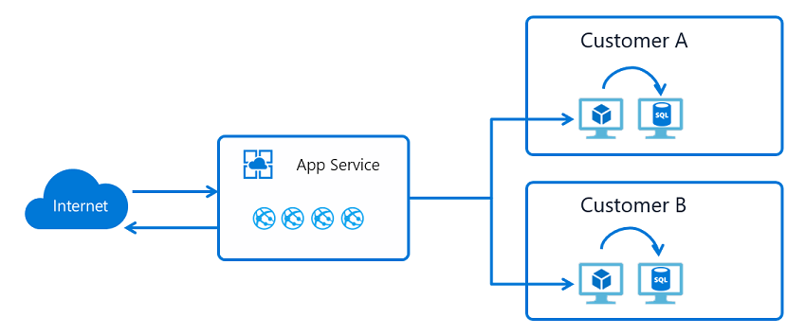

Key Components of App Service
- App Service Plan
- Defines the region, number of VM instances, pricing tier, and scaling options.
- Determines how much compute power (CPU, memory, storage) your app gets.
- You can host multiple apps under a single plan to optimize cost.

- Web Apps
- Used to host web applications and APIs.
- Supports frameworks such as:
- ASP.NET / .NET Core
- Java / Spring Boot
- Node.js / Express

- Python / Flask / Django
- PHP, Ruby, etc.
Can also run custom Docker containers.

- API Apps
- Special type of Web App designed for hosting RESTful APIs.
- Comes with built-in support for:
  - Swagger / OpenAPI
  - Authentication / authorization
  - CORS (Cross-Origin Resource Sharing)

- Mobile Apps
- Used to build backend services for mobile apps.
- Offers features like:
  - Push notifications
  - Offline sync
  - Authentication (Microsoft, Google, Facebook, etc.)

- Function Apps (Serverless)
- Runs small pieces of code (“functions”) on-demand without managing servers.
- Automatically scales based on triggers (HTTP requests, queues, timers, etc.).

    - App Service Features
Feature | Description
Multiple language & framework support | Run .NET, Java, Node.js, Python, PHP, or custom containers.
Continuous Deployment (CI/CD) | Integrate with GitHub, Azure DevOps, Bitbucket, or local Git for automatic deployment.
Scaling | Manual or automatic scaling based on CPU, memory, or schedule.
High Availability | Built-in load balancing and regional redundancy.
Custom Domains & SSL | Use your own domain name and add free or custom SSL certificates.
Authentication & Authorization | Easy integration with Azure AD, Facebook, Google, Twitter, etc.
Staging Environments | Use deployment slots (e.g., staging, production) for zero-downtime deployments.
Monitoring & Diagnostics | Integrated with Azure Monitor, Application Insights, and Log Analytics.
VNet Integration | Connect securely to on-premises or Azure Virtual Networks.
Backup & Restore | Automatically back up app content and configurations.

    - Deployment Options
You can deploy code to App Service using:
- Git / GitHub / Azure Repos
- ZIP or WAR files
- Azure CLI / PowerShell
- Docker containers
- Visual Studio / VS Code
- FTP / FTPS

    - Scaling and Availability
App Service supports:
- Vertical scaling (change pricing tier for more power)
- Horizontal scaling (increase instances automatically)
- Auto-scaling based on metrics (CPU usage, request count, etc.)
You can also use Traffic Manager with App Service for global load balancing across multiple regions.

    - Security Features
- Managed identities for secure access to other Azure services.
- Authentication/Authorization (“Easy Auth”) for quick setup.
- Private endpoints and VNet integration for network isolation.
- TLS/SSL encryption with automatic renewal of certificates.

- Pricing Tiers
App Service offers several pricing tiers:
Tier | Description
Free (F1) | Limited resources, for testing or learning.
Shared (D1) | Shared infrastructure, basic hosting.
Basic (B1–B3) | Dedicated VMs, suitable for dev/test.
Standard (S1–S3) | Auto-scaling, SSL, daily backups.
Premium (P1v2–P3v2, P1v3–P3v3) | Faster CPUs, better scaling, more features.
Isolated (I1–I3) | Runs in your own private network (App Service Environment).

- App Service vs. Virtual Machines
Feature | App Service (PaaS) | Virtual Machines (IaaS)
Infrastructure Management | Fully managed by Azure | Managed by you
Scaling | Built-in auto-scaling | Manual or scripted
Deployment Speed | Very fast (minutes) | Slower (need OS setup)
Flexibility | Limited (managed environment) | Full control
Maintenance | Azure handles patching | You handle OS & software updates

- AFD – AZURE FRONT DOOR
- It works on OSI layer 7
- It can distribute across backend pool
- It can route the traffic based on url / path based routing
- It supports WAF and CDN
- WAF is 2 types : Detection and prevention

- Azure Front Door is Microsoft Azure’s global, scalable entry point for delivering high-performance, - secure applications to users anywhere in the world.

- Azure Front Door (AFD) is a cloud-based Application Delivery Network (ADN) that combines:
  - Global HTTP/HTTPS load balancing
  - Dynamic Site Acceleration (DSA)
  - Edge caching
  - SSL termination
  - Web Application Firewall (WAF)
  - Global failover and health probes
  - Zero-trust application security features

- It uses Microsoft’s global edge network (tens of thousands of edge POPs) close to users, reducing latency and improving reliability.

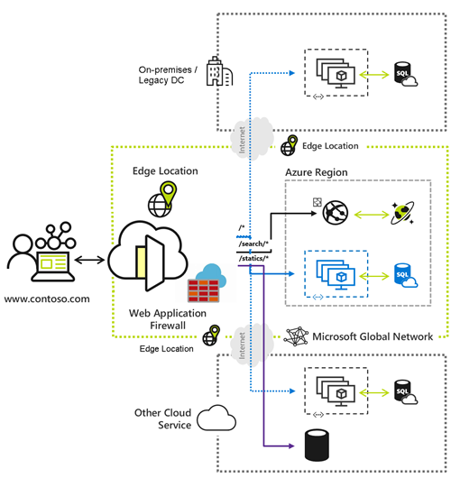

- Key Capabilities
- Global Load Balancing (Layer 7)
- Azure Front Door is an application-layer (Layer 7) load balancer.
- Features:
  - Route traffic based on URL paths, query strings, or headers.
  - Weighted or priority-based load balancing among backends.
  - Active health probes to detect server or region failures.

- Instant global failover: if one region goes down, traffic automatically shifts to the next healthy region.

- Dynamic Site Acceleration (DSA)
- AFD accelerates dynamic (non-cacheable) content by:
  - Route optimization (finding fastest network paths).
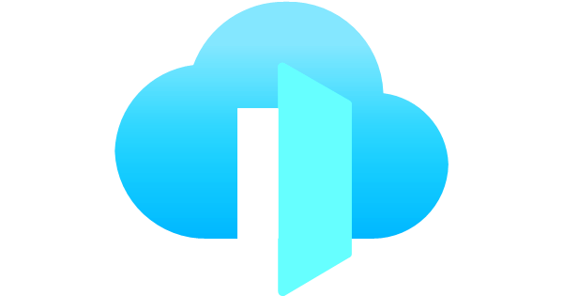
  - TCP/UDP optimization and connection pooling.
  - Anycast routing to nearest edge location.
- This reduces latency for APIs, e-commerce sites, or dynamic applications.

- Content Caching (Edge Caching)
- Front Door can cache static content like: Images, CSS / JS, Static HTML, Downloads
- Cached assets are served from edges nearest to users, improving performance.

- Security Features
- Azure Front Door provides multiple layers of security:
- Web Application Firewall (WAF) - Protects against:
  - SQL injection , Cross-site scripting, OWASP Top 10 vulnerabilities
  - Bot and DDoS attacks, Custom rules based on IP, headers, geolocation, user-agent, etc.

- DDoS Protection
  - AFD includes global DDoS mitigation built into the Microsoft edge network.

- TLS/SSL termination
  - Front Door handles HTTPS traffic at the edge with automatic certificate management.

- URL Routing and Rewriting
- Front Door works as a "smart traffic router":
- Route based on paths (e.g., /api/* → API backend; /static/* → CDN).
- Redirect (301/302) or rewrite paths.
- Host-based routing for multi-site applications.

- Custom Domains and Certificates
- You can map custom domains to Front Door and manage free TLS certificates from Azure-managed certificates.

- Integration with Azure Services
- Front Door integrates with:
  - Azure App Service
  - Azure AKS
  - Azure Storage Static Websites
  - Azure API Management
  - Azure Private Link (secure backend connections)

- Azure Front Door Architecture in Simple Terms
User Request → Nearest Azure Edge POP → Front Door → Backend Pool → Application
- Front Door handles: SSL termination, WAF filtering, Caching, Global routing, Health checking
You only receive clean, optimized traffic at your backend.

- Azure Front Door vs Azure Application Gateway
Feature | Azure Front Door | Application Gateway
Layer | Layer 7 (global) | Layer 7 (regional)
Scope | Global | Regional
Caching / CDN | Yes | No
WAF | Yes | Yes
Load balancing | Global | Local (within region)
Private Link | Yes | Yes
Best for | Global apps, acceleration | Internal or region-specific traffic

- Often, enterprises use both together:
- Front Door at the global edge
- App Gateway inside Azure region



- STORAGE ACCOUNT
- Symbol of storage account
Simple object storage
While creating name should be unique across all azure ,
All should be in lower case letters and numbers,
Char 3 – 24

Allow cross-tenant replication

Service endpoint : it will uses backbone network to connect to PaaS
private endpoint connects

After creating VM windows need to get access from networking under settings in storage to access for VM and se
lf ip

- An Azure Storage Account is a logical container that groups Azure storage services under a single namespace, accessible over HTTP/HTTPS.
- A Storage Account in Azure is a secure, scalable, highly available cloud storage container that holds all your Azure Storage data objects.
- It is the fundamental building block for Microsoft Azure’s storage services.
- It gives you:
  - A unique endpoint (e.g., https://mystorageaccount.blob.core.windows.net)
  - Authentication + authorization features
  - Security controls
  - Redundancy options (LRS, GRS, ZRS, RA-GRS, etc.)
  - Access to multiple storage services inside one account

- Storage Services Inside a Storage Account
- A storage account can host several storage types:

- Azure Blob Storage (Object Storage)
- Stores unstructured data like images, videos, documents, logs, and backups.
- Blob types:
  - Block blobs – best for files (media, docs)
  - Append blobs – optimized for logs
  - Page blobs – used by Azure VM disks
  - Containers → store blobs
  - Blobs → actual files/data

- Azure File Storage (Managed File Shares)
- Provides SMB – Server Message Block and NFS – Network File Server file shares
- Useful for:
  - Lift-and-shift apps, Shared drives, Kubernetes (AKS) file mounts

- Azure Queue Storage
- A messaging store for async communication between application components.
- Used for:
  - Background job queues
  - Microservice messaging
  - Distributed systems decoupling

- Azure Table Storage
- A NoSQL key-value database that stores large amounts of structured, non-relational data.
- Typical uses: Metadata storage, Logging, IoT data, User preference stores

- Azure Disk Storage (Managed Disks)
- Virtual machine disks are technically backed by page blobs inside storage, managed automatically by Azure.

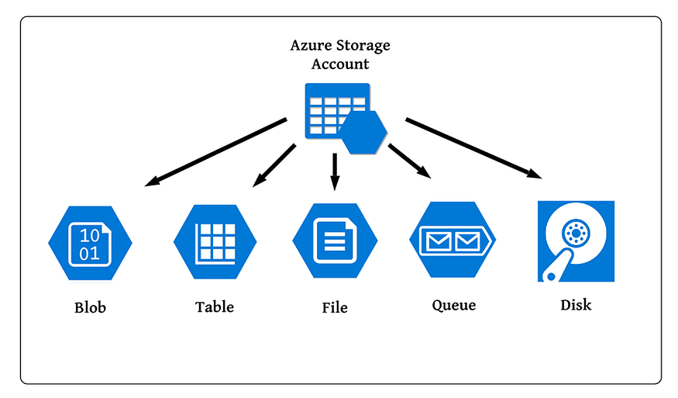

- Types of Storage Accounts
- There are multiple storage account types depending on workload:
- General-purpose v2 (GPv2) ⭐ Most Common
- Supports all storage services (blobs, files, queues, tables),
- Best for most applications.

- General-purpose v1 (GPv1)
- Older version, Limited features, Generally not recommended

- Blob Storage Account
- Optimized for blob workloads only,
- Supports Hot and Cool tiers.

- Premium Storage Accounts
- Provides SSD-backed storage for high-performance workloads.
- Types:
  - Premium Block Blob, Premium File Shares, Premium Page Blobs (Disks)
- Used for performance-critical systems (databases, VMs, SAP).

- Security & Access Features
Storage accounts provide robust access control:

- Authentication Methods
- Azure AD (RBAC) (recommended)
- Shared Key (Account Key)
- Shared Access Signatures (SAS)
- Managed Identities

- Network Security
- Allow from specific VNets (Private Endpoint)
- Firewall rules (IP restrictions)
- Private Link – fully private traffic
- Service Endpoints

- Encryption
- Data encrypted at rest (AES-256)
- Optional customer-managed keys
- TLS for data in transit

- Data Redundancy Options (Replication)
- Azure ensures durability by replicating data.
- Local Redundant Storage (LRS) : 3 copies within same datacenter.
- Zone Redundant Storage (ZRS) : Across availability zones.
- Geo-Redundant Storage (GRS) : Replicated to a paired region (asynchronous).
- Read-Access GRS (RA-GRS) : Same as GRS but with read access to secondary region.
- GZRS / RA-GZRS : Zone redundancy + geo-replication.

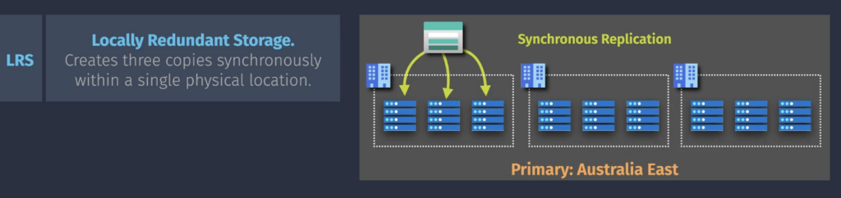

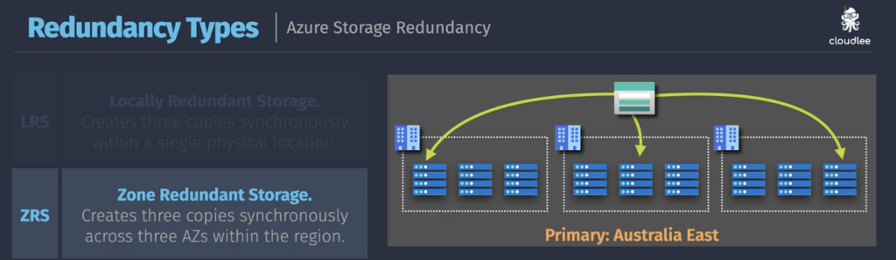

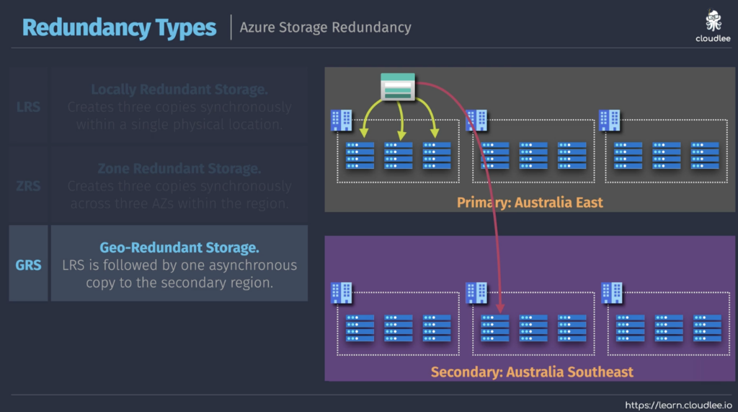

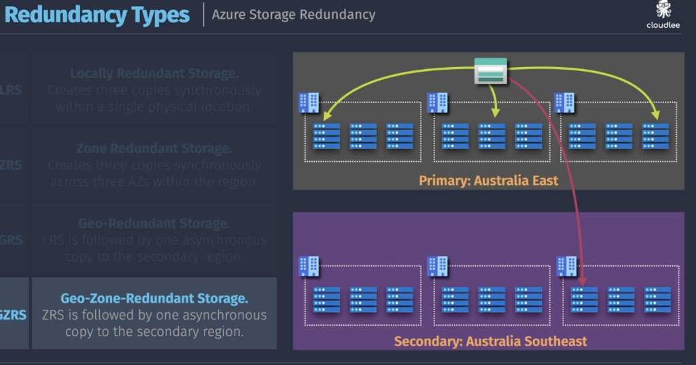

- Performance & Access Tiers
- For Blob Storage:
  - Hot – frequently accessed
  - Cool – infrequently accessed (≥30 days)
  - Archive – rarely accessed (≥180 days)
Archive → cheapest storage, highest read cost.

- Consistency Models
- Azure Storage provides strong consistency:
  - Read after write
  - Read after update
  - Read after delete

- Typical Use Cases
- Backup and disaster recovery
- Hosting static websites
- Log storage
- Big data analytics
- VM disks
- File shares for apps
- IoT data ingestion
- Data lakes (with Data Lake Gen2 enabled)

- Advanced Feature: Data Lake Gen2
- A Storage Account can be enabled with Hierarchical Namespace (HNS) to act as a Data Lake, enabling:
  - File system semantics, ACL-based security, Big Data analytics integration (Synapse, Databricks, Hadoop)
- This turns blob storage into a full big data file system.

- High-Level Architecture
┌───────────────────────┐
│ Azure Storage Account │
└───────────────────────┘
│
┌─────────────────────────────────────────────────┐
│ Services inside the account │
└─────────────────────────────────────────────────┘
│ │ │ │
┌────────┐ ┌────────┐ ┌────────┐ ┌────────┐
│ Blobs │ │ Files │ │ Queue │ │ Tables │
└────────┘ └────────┘ └────────┘ └────────┘

- IDENTITY MANAGEMENT ( STORAGE ACCOUNT ACCESS )

No — identity management and storage access in Azure are related, but they are not the same thing. They solve different problems and operate at different layers.

- Identity management in Azure is handled primarily by Azure Active Directory (Azure AD / Entra ID).
- It is responsible for:
- Managing users, groups, and service principals
- Authentication (who are you?)
- Conditional access policies
- Multi-factor authentication (MFA)
- Identity governance (PIM, access reviews, etc.)
- Identity management = who you are and how you authenticate

- Storage access means permissions to read/write/manage data in Azure Storage services:
- Blob Storage
- File Shares
- Queues
- Tables
- Data Lake Storage Gen2

- Storage access is controlled using:
      - Access Keys : Admin Level
      - SAS Tokens (Shared Access Signatures) Key : Edit to what level is done.
      - Role to Role / RBAC
      - Resource to Resource / ACLs (for Data Lake) : POSIX-style permissions on files/folders
- Storage access = what you can do with the data

Identity management and storage access work together, but they are not the same:
Identity Management | Storage Access
Manages identities (users, groups, apps) | Controls what those identities can do in storage
Authentication | Authorization
Handled by Azure AD / Entra ID | Handled by Azure RBAC, ACLs, SAS
“Who are you?” | “What are you allowed to do?”

- Identity Management in Azure refers to all the systems, services, and processes Microsoft provides to manage:
- Who a user is (identity)
- How they sign in (authentication)
- What they can access (authorization)
- How their identity is governed (lifecycle + compliance)
This is primarily handled by Microsoft Entra ID (formerly Azure Active Directory), which is Azure’s cloud-based Identity and Access Management (IAM) platform.

- Core Functions of Azure Identity Management : Azure Identity Management involves several major components:
- Microsoft Entra ID (Azure AD) → The identity store
- Authentication → Verifying identities
- Authorization → Defining access to resources
- Conditional Access → Context-based access policies
- Identity Governance → Lifecycle, compliance, and auditing
- Privileged Identity Management (PIM) → Securing admin accounts
- Identity Protection → Detecting risky sign-ins
- Hybrid Identity (Azure AD Connect) → Integrating on-prem Active Directory

- Microsoft Entra ID (Azure AD)
- Azure’s central identity service.
- This is where users, groups, roles, and devices are stored.
- What it does:
- Provides authentication for Azure, Microsoft 365, and SaaS apps
- Provides authorization through role assignments
- Enables Single Sign-On (SSO)
- Supports OpenID Connect, OAuth2, SAML
- Manages identities for cloud and hybrid environments
- Every Azure subscription depends on an Entra ID tenant for identity.

- Authentication in Azure
- Authentication is how Azure proves you are who you say you are.
Azure supports:
- Basic authentication : Username + password
- Strong authentication : Multi-Factor Authentication (MFA)
Email/phone verification
One-Time Passwords
- Password less authentication : Windows Hello for Business
Microsoft Authenticator App
FIDO2 security keys (USB/Bluetooth NFC keys)
- Federation : Integration with AD FS
External identity providers (Google, Facebook, GitHub, etc.)

- Authorization in Azure : Authorization defines what a user can do once authenticated.
Azure uses:
- Azure RBAC (Role-Based Access Control) : Controls access to Azure resources like:
  - Virtual machines
  - Storage accounts
  - Networks
  - Databases
Roles include: Reader, Contributor, Owner, Custom roles
RBAC answers: What resources can this identity access in Azure?

- App-Based Authorization : Controls access to enterprise applications.
Examples: Microsoft 365, SharePoint, Dynamics 365, SaaS apps like Salesforce, ServiceNow
Uses app roles, delegated permissions, and OAuth2 scopes.

- Conditional Access : Conditional Access is Azure’s policy engine that grants or blocks access based on conditions such as: Location,
Device compliance
Risk score
User or group
Application type
Session context

Examples of policies:
- Deny login from high-risk countries
- Require MFA only when accessing sensitive apps
- Allow access only from managed devices
Conditional Access enforces Zero Trust Security (“never trust, always verify”).

- Identity Governance : Used to automate identity lifecycle and maintain compliance.
It includes:
- Access Reviews : Regularly check who should keep what access.
- Entitlement Management : Bundles access into “Access Packages” for easy assignment.
- Lifecycle Workflows : Automatic account creation, updates, or removal.
- Compliance : Supports regulations like GDPR, ISO, SOC, HIPAA.

- Privileged Identity Management (PIM) : PIM protects administrator and high-privilege accounts.
It provides:
- Just-in-Time access → Admin role activated only when needed
- Approval workflows → Requires manager/security approval
- Time-bound permissions
- Session logging and auditing
- Alerts for unusual privilege use

This reduces risks like:
- Stolen admin credentials
- Permanent global admin access
- Insider attacks

- Identity Protection : Uses machine learning to detect:
- Risky sign-ins
- Impossible travel (logging in from two distant countries quickly)
- Password spray attacks
- Leaked credentials
- Compromised accounts

Actions can include:
- Blocking the sign-in
- Requiring password reset
- Triggering MFA
- Notifying security teams

- Hybrid Identity (Azure AD Connect) : Organizations using on-premises Active Directory can sync it to Azure using Azure AD Connect.
Supports three types of authentication:
- Password Hash Sync (most common)
- Pass-Through Authentication
- Federation (ADFS)
Allows a single identity to be used both on-prem and in cloud.

- External / B2B / B2C Identities : Azure also supports:
- B2B (Business-to-Business) : Invite external users (partners/vendors) into your tenant.
- B2C (Business-to-Consumer) : Build consumer-facing apps with identity (Google, Facebook, email login).

- Monitoring & Logging
- Azure provides logs to track identity activity:
- Sign-in logs
- Audit logs
- Risk detections
- Access reviews
- Conditional Access insights

These integrate with: Microsoft Sentinel, Defender for Cloud, SIEM/SOAR tools

- IMAGE CREATION

- Image creation refers to building a virtual machine (VM) image that can be used to deploy identical, preconfigured VMs at scale.
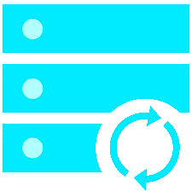
- An Azure image is a template containing the OS (Windows/Linux) plus optional customizations such as: Installed applications
  - Configured services
  - Security configuration
  - System updates
  - Environment files
- It’s a core part of Azure’s deployment and automation ecosystem, enabling standardized, repeatable, and secure VM provisioning.
- Images allow you to create multiple VMs with the same configuration for consistency and automation.

- Types of Images in Azure
Azure supports several types of VM images:
- Platform Images : Provided by Microsoft and third-party publishers
Examples: Windows Server 2022, Ubuntu 22.04 LTS, Red Hat Enterprise Linux,
These are base images you use to create new VMs.

- Custom Images : Created by users, typically from:
- A generalized VM (using Sysprep for Windows or waagent for Linux)
- A managed disk
Custom images contain your organization’s configuration.

- Azure Compute Gallery (formerly Shared Image Gallery) Images
Used to : Organize images, Version them, Replicate them across regions, Scale VM deployments efficiently
Allows enterprise-level image management.

- Specialized Images : Captured without generalizing (no Sysprep).
They preserve: User accounts, Machine identity, Installed software, Used for lift-and-shift scenarios.

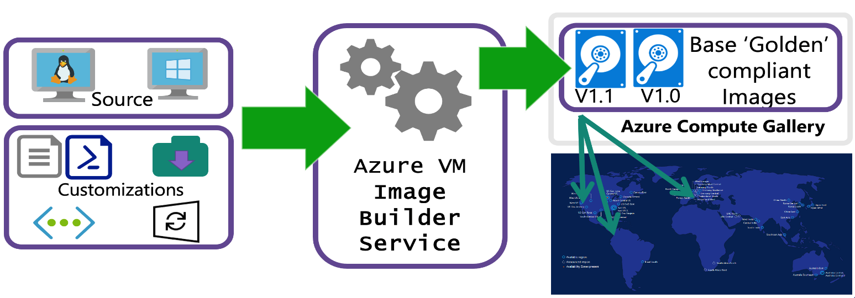

- How Image Creation Works in Azure
- There are multiple methods. Here’s each in detail.

- Create Image from an Existing VM
Steps:
    - Prepare the VM : Generalize (Windows: sysprep, Linux: waagent -deprovision+user)
    - Deallocate and stop the VM
    - Use "Capture" option in Azure portal
    - Store the image as:
      - A standalone Managed Image, or
      - An image version in Azure Compute Gallery
This lets you clone the VM repeatedly.

- Create Image from a Managed Disk
- If you have a VM disk (e.g., OS disk), you can create an image directly:
- No need to recreate the VM
- Useful after deleting the VM but retaining the disk

- Using Azure Compute Gallery : Best for enterprise scaling.
- Features: Image versions,
  - Replication to multiple regions,
  - Scaling improvements using caching,
  - RBAC access control,
  - Image lifecycle management
- Example flow: Create a Gallery, Create an Image Definition, Create Image Versions, Deploy VMs from gallery images

- Azure Image Builder (AIB) : A service that automates image creation.
- Based on HashiCorp Packer, but fully managed.
- What it can do:
  - Build images from base images
  - Run scripts (PowerShell / Bash)
  - Install software
  - Apply security hardening
  - Create output images in Compute Gallery
- Great for CI/CD pipelines and DevOps workflows.

- Image Generalization vs Specialization

Type | Generalized Image | Specialized Image
Machine Identity | Removed | Preserved
User Accounts | Removed | Preserved
Use Case | Mass deployment | Migration, cloning
Tools | Sysprep / waagent | None required

- Common Uses of Azure Images :
- Standardizing environments : Every VM starts identical.
- Scaling out application servers : Deploy hundreds of identical VMs quickly.
- Dev/Test environments : Same base environment for all developers/testers.
- Golden images for security compliance : Images include: Updates, Security patches, Hardening configurations, Disaster recovery
- Quickly recreate critical systems.

- Image Creation Options Summary
Method | When to Use
Capture from VM | Simple customizations
Managed disk → image | VM deleted but disk retained
Azure Compute Gallery | Enterprise scaling, versioning
Azure Image Builder | Automated, DevOps, repeatable image builds
Specialized images | Migration, preserve machine state

- VMSS – VIRTUAL MACHINE SCALE SET
- A Virtual Machine Scale Set is an Azure resource that lets you deploy a set of identical VMs that can automatically scale in or out based on demand.
- It is commonly used for high-availability applications, large-scale distributed workloads, and containerized environments.
- VMSS (Virtual Machine Scale Sets) is a compute service that lets you deploy, manage, and automatically scale a group of virtual machines.
- VMSS ensures : High availability
  - Automatic scaling
  - Load balancing
  - Simplified VM deployment and management

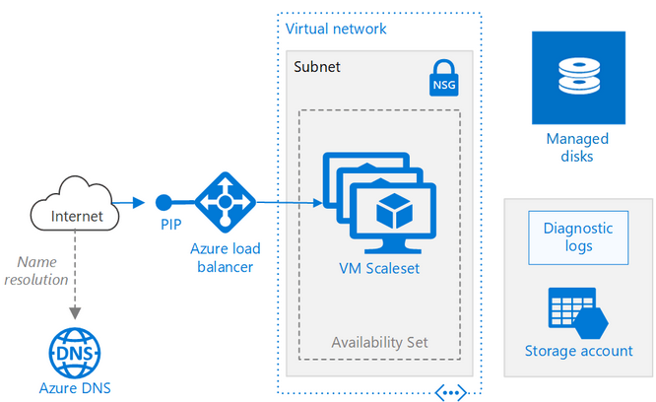
Architecture of VMSS

- Types of Scaling :
- Vertical scaling : Upgrade of Hard Ware size
- Ex : database servers / file share servers

- Horizontal Scaling : Adding up machines to distribute the load balance
- Ex : App server, web server.

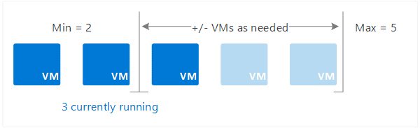

- Depends on load machines get increased to balance load
- If load decreases, machines reduce.

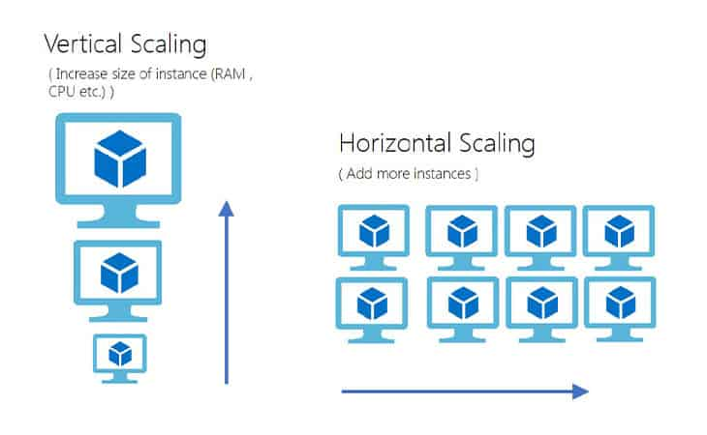

- If machines deleted, data also deleted
- so Database and file share server wont use Horizontal scale
- But in vertical case Database need data as machines don’t delete so,
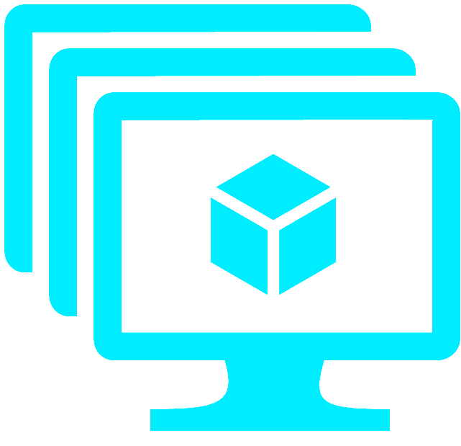
- Set a CPU usage condition in Azure to automatically add or remove instances( Size ).

Key Characteristics of VMSS
- Uniform Configuration : All VMs in a scale set use the same configuration:
- OS (Linux/Windows), VM size, Storage options, Network configuration,
- Application installation (via custom script, cloud-init, ARM/Bicep, or VM extensions)
This creates consistent behavior across the entire fleet.

- Automatic Scaling : VMSS supports autoscaling in two ways:
    - Manual Scaling : You explicitly set the number of instances
(e.g., 5 VMs → 10 VMs).
    - Auto Scale Policies : Scale based on metrics like:
      - CPU usage, Memory (through custom metrics), Disk I/O
      - Queue length (Service Bus, Storage Queues),
      - HTTP request count (App Insights)
      - Custom metrics (Azure Monitor)
        - For example: If CPU > 70% for 10 minutes → add 2 VMs
If CPU < 20% for 20 minutes → remove 1 VM

- Integration With Load Balancing : VMSS integrates with:
- Azure Load Balancer (Layer 4): for non-HTTP traffic
- Application Gateway (Layer 7): for HTTP/HTTPS with WAF support
This ensures smooth distribution of traffic across VM instances.

- High Availability & Fault Tolerance :
- VMSS automatically spreads VMs across: Fault domains (hardware racks)
  - Update domains (maintenance groups)
  - Zones (Availability Zones for regional resiliency)
- This protects the application against : Hardware failures,
  - Data center outages
  - Planned maintenance

- Flexible Or Uniform Orchestration Modes : VMSS has two modes:
  - Uniform Orchestration (default)
- All VMs must be identical.
- Best for large-scale stateless workloads.
  - Flexible Orchestration
- Supports a mix of VM types and sizes.
- Allows attaching existing standalone VMs.
- Supports availability sets.
- Better for stateful or diverse applications.

- Image Support : You can deploy VMs using:
- Azure Marketplace images
- Custom images from an Azure Compute Gallery
- Shared image galleries
- Managed images
- This ensures predictable and consistent deployment.

- Automatic OS and Application Updates : VMSS supports:
    - Rolling upgrades : Instances are updated gradually to avoid disruption.
    - Automatic OS image updates : Azure can automatically replace VMs with the latest patches.

- Integration With DevOps/Infrastructure Tools
- VMSS works seamlessly with: Azure DevOps Pipelines
  - GitHub Actions
  - Terraform / Bicep / ARM
  - Ansible / Chef / Puppet
This makes VMSS ideal for CI/CD and infrastructure automation.

- Common Use Cases
- Web servers & microservices : Scale dynamically based on incoming traffic.
- Big data & analytics clusters : Batch processing, HPC, and distributed computing.
- Container orchestration : Run containerized workloads without Kubernetes (VMSS can host Docker, etc.).
- Gaming servers : Support fluctuating demand.
- Stateless application backends : Where individual VM failures don’t impact the overall system.

- Benefits of Using VMSS
Benefit | Description
Scalability | Handles thousands of VMs automatically
Cost efficiency | Scale in to reduce costs when load is low
High availability | Fault domain and zone support
Automation | Automatic image/OS updates, autoscaling
Consistency | Identical VMs ensure predictable behavior
Integration | Works with load balancers, networks, DevOps pipelines

Note : Need to create machine as replica of running machine
Use custom image to create machine as vmss

- AZURE BASTION
- Azure Bastion is a fully managed service in Microsoft Azure that provides secure RDP and SSH access to your virtual machines without exposing them to the public internet.

- What Azure Bastion Does
- Allows you to connect to VMs through your browser using the Azure portal.
- Eliminates the need for public IP addresses on VMs.
- Protects against port scanning, brute-force attacks, and other internet-exposed risks.
- Provides seamless RDP/SSH connections over SSL (port 443).

- Key Features
- No public IP needed on VMs.
- Secure access using TLS.
- Zero Trust–friendly—VMs stay in private networks.
- Integration with Azure AD for authentication (for some VM types).

- Session recording (optional).
- Native client support (SSH/RDP clients via Bastion).
- High availability because it is a PaaS (Platform as a Service).

- How It Works
- You deploy Azure Bastion into a virtual network.
- Azure creates bastion host instances within a special subnet: AzureBastionSubnet.
- You connect to VMs through the Azure portal, CLI, or native tools.
- Bastion establishes the session over its secure connection—your VM stays private.

- When to Use Azure Bastion
- Use it when you want:
  - Secure VM access without internet exposure.
  - To follow best practices for cloud security.
  - Simple, managed RDP/SSH access.

- Azure Bastion Subnet Requirements (Simple)
- Subnet name must be: AzureBastionSubnet
(The name must match exactly — no changes allowed.)
- Minimum subnet size: /26
(Larger is allowed: /25, /24, etc.)
- Must be in the same VNet where your VMs are located.
- No NSGs should be directly attached to the AzureBastionSubnet
(You can use NSGs on other subnets.)
- Requires a public IP (Standard SKU) for the Bastion host.
- No UDRs (User Defined Routes) that block required Bastion traffic.

- While creating Subnet for Bastion
- While creating Subnet On the Subnet name or Up to the name,
- There is a name known as purpose select azure bastion,
- Name automatically types as AzureBastion

- RECOVERY SERVICE VAULT

Recovery Services Vault = Service Recovery Vault = Azure Recovery Services Vault
{ sir note
Backup : Image level backup, File level backup
Site recovery : Disaster recovery

After replication enabled – disk will replicate

You need to create RSV at target location, resource group, Vnet and subnet
Storage account gets created automatic

Types of backup
- Schedule backup
Complete state takes a snap and upload to rsv
Retension period is 30days

- On demand backup }

- A Recovery Services Vault is a management container/resource in Azure that is used to:
- Store backup data : (from Azure Backup)
- Store Site Recovery metadata and orchestration info : (from Azure Site Recovery/ASR)
- Orchestration = automated steps that ensure your workloads fail over to a secondary site in the correct order with minimal downtime.
- It provides a centralized, secure, scalable location for all workload-level protection data related to backup and disaster recovery.

- Recovery Services Vault (sometimes informally reversed as “service recovery vault,” but the official name is Azure Recovery Services Vault).

- A Recovery Services Vault in Azure is : A secure, scalable repository that stores backups and disaster-recovery replication data, enabling VM restore, file restore, database restore, and region failover.

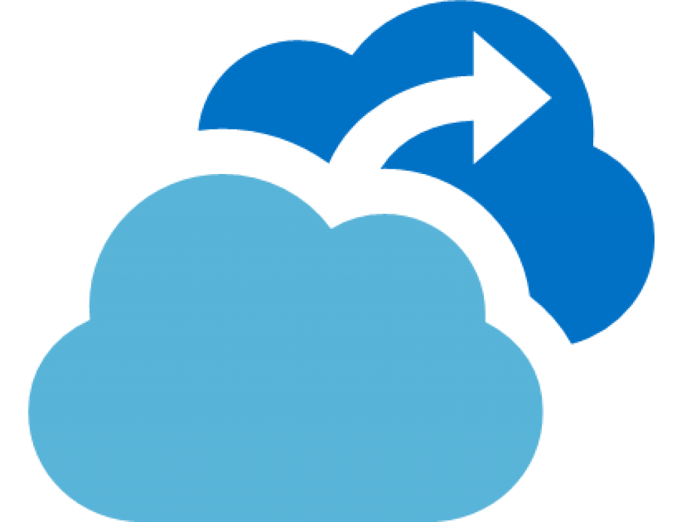
- The Recovery Services Vault Contains : A vault stores :
- Backup Data :- Azure Virtual Machine backups
- Azure Blob backups (via policies)
- Azure Files backups
- Azure SQL in-VM backups
- On-premises backups via MARS agent
- DPM/MABS backup data
- App-consistent snapshots & recovery points

- Site Recovery Metadata :- VM replication configuration
- Replication health/status
- Failover plans
- Recovery plans (automation scripts, order of operations)

- Policies & Settings :- Backup schedules
- Retention periods
- Soft-delete timelines
- Access control (RBAC)
- Security settings (encryption, immutable backups)

A vault does not run workloads; it simply stores backup/DR data, metadata, and policies.

- How the Vault Protects Data :- Azure Recovery Services Vault includes multiple security features:
- Soft Delete : Prevents accidental or malicious deletion of backups (data retained 14–90 days depending on the workload).

- Multi-layered Encryption :- Encryption in transit
- Encryption at rest (Azure Storage + optional customer-managed keys)
- Support for Azure Key Vault integration

- Backup Security Settings :- Alerts for delete operations
- “Security PIN” required for destructive actions.
- Enhanced security for hybrid backups (MARS agent)

- Immutability (for certain workloads) : Backups cannot be modified or deleted for a set duration.

- How Recovery Services Vault Works (Architecture)
- Backup Workflow
- Azure VM/File/SQL/MARS agent triggers backup via a schedule.
- Data is snapshotted or transferred to the vault.
- Vault stores recovery points based on retention rules.
- You can restore a VM, disk, file, or database from these recovery points.

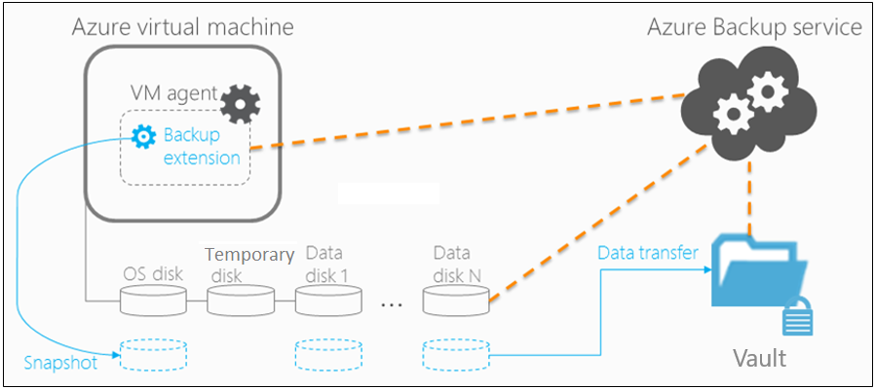

- Site Recovery Workflow
- You configure replication from source (Azure VM or on-prem server).
- Vault stores replication metadata and coordinates replication.
- During a disaster, you can failover to a secondary region/site.
- After the primary site is restored, you can failback.

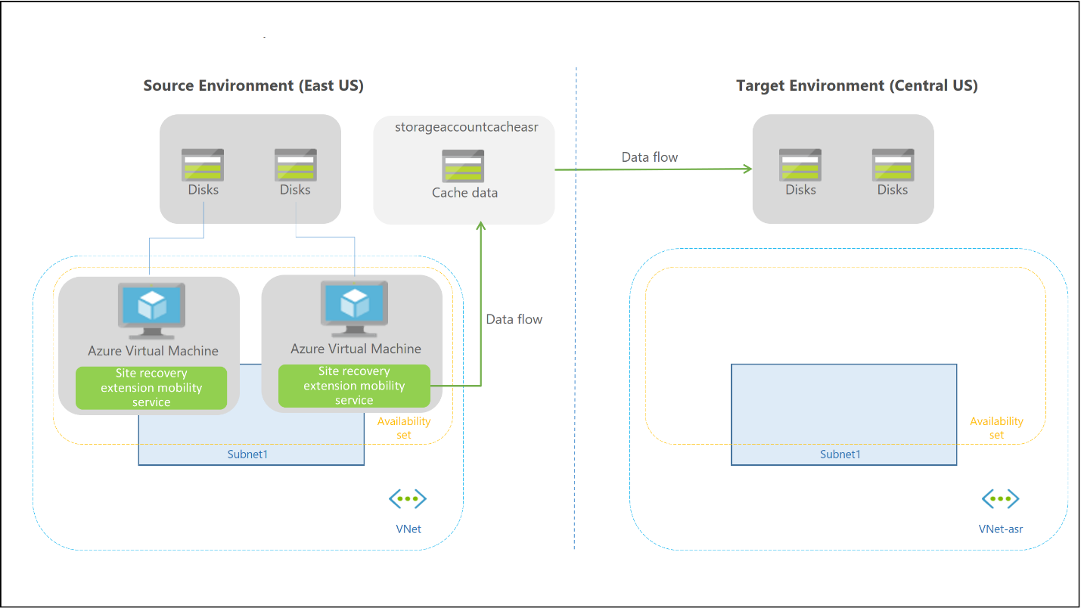

- Scenarios Where a Recovery Services Vault Is Used
- Azure VM Backup : Daily/weekly/monthly backup
- Point-in-time restores
- Disk-level or whole-VM restore

- On-Premises Server Backup : Using the MARS agent (Microsoft Azure Recovery Service)
- Using DPM/MABS

- Azure Site Recovery
- Azure VM → Azure region replication
- VMware → Azure replication
- Hyper-V → Azure replication
- Physical servers → Azure replication

- Azure File Shares & Blob Backup : Long-term retention
- Immutable backup capability (depending on storage tier)

- Recovery Services Vault vs Backup Vault
- Azure now has two types of vaults:
Feature | Recovery Services Vault | Backup Vault
Workloads supported | Most backup types + Site Recovery | Newer workloads (e.g., Azure Blob, Azure SQL MI LTR)
Supports Azure Site Recovery | ✔ Yes | ❌ No
Management model | Classic backup model | Modern data-protection model
Recommended for | VMs, file shares, MARS, DPM, ASR | Newer PaaS workloads

- Most enterprise DR solutions still rely on Recovery Services Vault.

- Limitations of Recovery Services Vault
- Vault cannot be moved across Azure regions.
- Storage redundancy (LRS/GRS) is set at creation and cannot be changed.
- Per-subscription vault limits apply (usually 500 vaults).
- Cannot mix Backup Vault and Recovery Services Vault policies.

- RSV – RECOVERY ( RECOVERY SERVICE VAULT RECOVERY )
- RSV Restore refers to the process of restoring backup data stored in an Azure Recovery Services Vault (RSV).
- An Azure Recovery Services Vault is a secure, isolated, Azure-managed backup vault used by Azure Backup and Azure Site Recovery.
- RSV serves as the source of truth for all backup data—VM backups, disk backups, file/folder backups, SQL backups, SAP HANA backups, and on-prem workloads.
- So RSV Restore = retrieving and recovering backed-up data stored inside a Recovery Services Vault.

- How Azure RSV Backup and Restore Architecture Works
- When you back up a resource (Azure VM, SQL DB, files, etc.):
- Snapshot taken : Azure Backup triggers a VSS snapshot (Windows) or fsfreeze (Linux) to create a crash-consistent or application-consistent snapshot.

- Snapshot transferred to Recovery Services Vault : The snapshot is copied from the storage account to a Recovery Services Vault.

- Vault stores the data as restore points : Restore points are immutable and secured by:
- Soft Delete, Multi-user Authorization, Azure RBAC, Encryption

- During restore, Azure retrieves data from :- Instant Restore snapshots (for recent restore points) or Vault backup storage (for older restore points)

- RSV Restore Types : Depending on what was backed up, you get different restore types:
- Azure Virtual Machine Restore : Restore options:
  - Create a new VM : Restores the full VM (OS disk + data disks)
  - Restore disks only : Disks are restored to a storage account; you rebuild a VM manually.
  - Replace existing VM : Stops the current VM
    - Replaces its disks with restored disks
    - Retains network configuration
- Restore files/folders from a VM backup :Mounts a temporary disk → You download specific files.

- Azure Disk Backup Restore : Entire disks, Individual disks, Only selected restore points
- Disk backups are faster than full VM restores since they use snapshot-based incremental backup.

- SQL Server Restore (IaaS VM) : Granular restore
- Database-level restore, Point-in-time restore, Log backups restore

- SAP HANA Restore :- Full database restore, Log restore, Point-in-time restore

- Azure Backup Server/DPM (On-Premises) : Restores:
- Hyper-V VMs, Files/folders, Bare metal recovery, VMware workloads,
- Backup data is stored in RSV and restored to on-prem servers.

- RSV Restore Workflow (Step-by-Step)
- Open Recovery Services Vault
- Go to Backup Items or Backup Instances
- Choose the workload (Azure VM, SQL, Disk Backup, etc.)
- Select Restore
- Pick a Restore Point (daily/weekly/monthly)
- Select Restore Type (full VM, disk, file-level, etc.)
- Choose target location
- Configure the restore (encryption, access, overwrite mode)
- Submit job
- Monitor under Backup Jobs

- Security and Protection During RSV Restore : Azure Backup applies strong security:
- Soft Delete : Retains deleted backups for 14+ days,
- Restore still possible even if backups were intentionally deleted

- Multi-User Authorization (MUA) : Prevents unauthorized deletes via approval workflows.

- Encryption :- Stored encrypted using Azure-managed keys,
- Option for customer-managed keys (CMK)

- Immutable Vault :- You can lock the vault so backups cannot be modified or deleted.

- RSV Restore Performance : Performance depends on:
- Data source :- Instant Restore snapshots → fastest,
- Vault storage restore → slower
- Size of the VM/disks
- Region throttling and network speed : Typical performance:
- Small VMs restore in minutes
- Large multi-terabyte disks may take hours

- Limitations of RSV Restore
- Cannot restore across regions unless you enabled Cross-Region Restore (CRR).
- Cannot restore a VM to a different subscription unless using disk restore.
- File-level restore does not support encrypted Linux VMs.
- “Replace existing VM” is not supported for: Encrypted VMs with ADE
  - VMs with ephemeral OS disks
  - Shared disk scenarios

- When Do You Use RSV Restore? : You use RSV Restore when:
- A VM has crashed and must be rebuilt
- You need to roll back to an earlier safe state
- You deleted data accidentally and need file-level recovery
- You need to restore a database to a specific timestamp
- Disaster recovery (after ransomware attack)

- AZURE SQL ( AZURE STRUCTURED QUERY LANGUAGE )
( Sir explanation
- We have 2 databases 1st and 2nd
- So 1st database is primary with R/w permission and 2nd is second only with read permission
- When 1st database is down due to issue then 2nd database becomes primary as R/W permission with sink data and 1st becomes secondary same as read permission
- Database can be IasS model or PaaS model

- Windows – to maintain on your own, cloud provider is not responsible in Iaas

  - Sql software download
  - Install
  - Sql licensing
  - Configuration setup
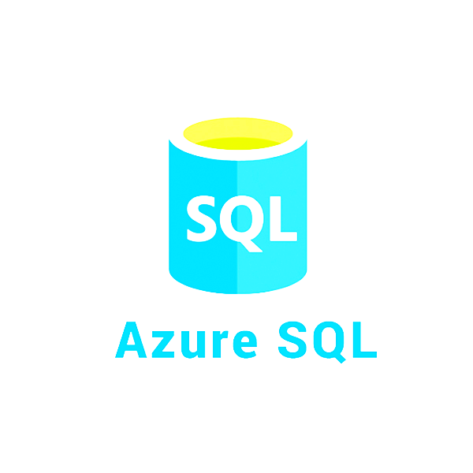
- Paas is come with rg and vm
- Connect internally using private endpoint in paas

- To sql to server connect ssms
- Replica : database to database but to different region only 1 database
- Failover group : server level i.e complete database server

- For connecting replica database
- Use only private endpoint no public
- It connects as it is VM to sql server internal
- You need server name and sql authenticate to connect sql server from vm
- You use secondary as report generate and read format.
- As there is heavy load on primary server you can not or take time to generate report from 1st server
- If primary fails then bring back 2nd server as primary and vice versa )

( Main Notes )
- Azure SQL is a family of fully managed cloud-based database services offered by Microsoft Azure.
- It is built on the Microsoft SQL Server engine but delivered as a PaaS (Platform as a Service) instead of a system you install and maintain yourself.

- Microsoft uses the term “Azure SQL” to refer to three related services:
- Azure SQL Database (PaaS) : A fully managed single database or elastic pool.
- Features:
  - Automatic backups
  - Automatic patching
  - Automatic scaling
  - Automatic high availability
  - No server maintenance
- Use case: For applications that need a cloud-native SQL database without managing servers.

- Azure SQL Managed Instance (PaaS) : A managed database service that is very close to full SQL Server.
- Features:
  - Supports SQL Agent
  - Supports cross-database queries
  - Easy migration from on-prem SQL Server
- Use case : For organizations moving from existing SQL Server but still want cloud-managed benefits.

- SQL Server on Azure Virtual Machine (IaaS) : SQL Server running on a Windows or Linux VM.
- Features: You maintain the OS and SQL Server
  - High flexibility and customization
- Use case: When you need full control over SQL Server.

- Azure SQL is popular
- No hardware to manage
- Built-in backup & disaster recovery
- Built-in intelligent tuning
- Easy scaling
- Global availability

- What is a Replica (in Azure SQL)?
- A Replica is a copy of your database stored on another server or region.
Replicas are used for:
- High availability (HA) : Ensures your database stays online even if one local server fails.
- Read scaling : You can offload read-only queries to replicas to reduce load on the main server.
- Disaster recovery (DR) : If a region goes down (e.g., an entire Azure datacenter outage), another region has a copy ready.

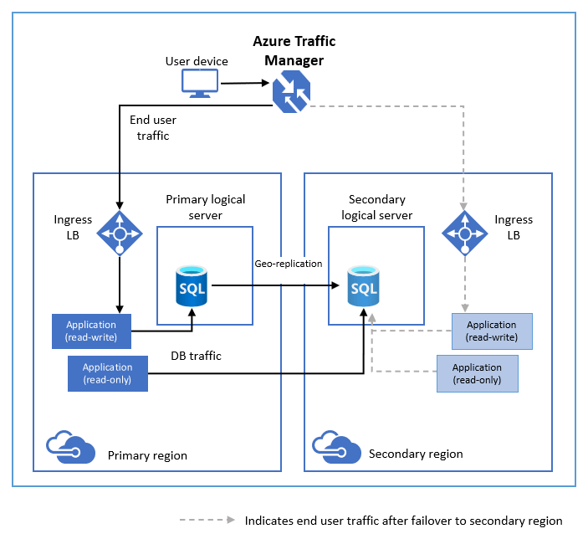
- Types of Replicas in Azure SQL
- Primary Replica : This is the main, read-write database where:
- INSERT, UPDATE, DELETE, CREATE
operations happen.

- Secondary Replicas : Read-only copies of the primary.
- Used for: running analytics, heavy reporting, backups, geo-replication

- Types of replication mechanisms in Azure SQL
- High Availability Replicas (Built-in HA) : Azure SQL automatically uses multiple replicas within the same region.
- You get: 1 Primary, 3 Secondaries
- These are managed by Azure—no setup required.

- Active Geo-Replication
- You can create up to 4 readable geo-replicas in different geographical regions.
  - Example: Primary in East US, Replicas in West US, Europe, Asia
- Used for: global app performance, disaster recovery across continents

- Auto-failover groups
- Automatically manages: multiple replicas, failover between regions, connection redirection
Best for multi-region apps.

- What is Failover? (in Azure SQL)
- Failover is the process of switching from the primary replica to a healthy secondary replica when a failure occurs.

- If your main server crashes, Azure immediately switches traffic to a backup server (replica) so your application continues running.

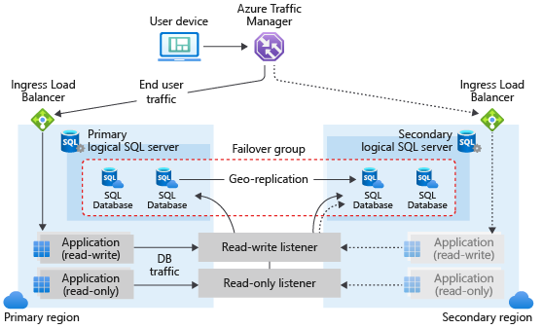
- Types of Failover
- Automatic Failover : Happens without human intervention.
- Triggered by failures like: hardware crash, network failure, power loss, Azure zone outage
- Azure detects these immediately and moves traffic to a secondary replica.
- This ensures high availability.

- Manual Failover : Initiated intentionally by an admin or system.
- Reasons: testing disaster recovery, planned maintenance, performance testing

- Failover in Different Azure SQL Services
- Azure SQL Database & Managed Instance
- They use:
  - Built-in automatic failover inside a region
  - Auto-failover groups for cross-region failover

- Failover Process (Simplified)
- Primary replica becomes unhealthy
- Azure detects the problem
- A secondary replica is promoted to primary
- DNS/endpoint redirects traffic
- The application continues without downtime (or minimal downtime)

- Failover groups allow: Multiple databases, Across multiple regions, To fail over automatically, Using a single connection endpoint
- Useful for large enterprise systems with many databases.

- Replica vs Failover (Simple Comparison)
Concept | Meaning | Purpose
Replica | Copy of the database | Availability, read scaling, DR
Failover | Switching to a replica when the primary fails | Continuity and uptime
Geo-replication | Replicas in different regions | Disaster recovery
Failover group | Automatic multi-region failover | Enterprise-level resilience

- Simple to remember
- Azure SQL → Cloud-based SQL Server family (fully managed)
- Replica → Read-only or backup copies of your database
- Failover → Switching from primary to replica on failure
- Azure handles most of this automatically

- HUB AND SPOKE ARCHITECTURE
- The Hub-and-Spoke architecture is a cloud networking pattern in Microsoft Azure used to organize, secure, and scale enterprise environments.
- It follows the principle of centralizing shared services (hub) while isolating workloads (spokes).

- Core Concept
    - Hub Virtual Network
- A central virtual network that acts as:
  - The connectivity core
  - The place where shared, common, and infrastructure services are deployed
- Common hub services:
- Azure Firewall / Network Virtual Appliances (NVAs)
- VPN Gateway
- ExpressRoute Gateway
- Azure Bastion
- Private DNS Resolver
- Identity and monitoring services

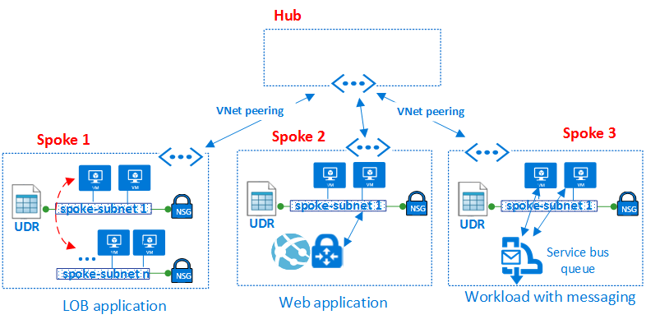
- Spoke VNets
- Spoke networks are workload-specific or environment-specific VNets.
- Spokes typically contain:
  - Application tiers (web/app/db)
  - Microservices
  - Dev/Test/Prod environments
  - Team-specific workloads
- Each spoke is isolated but can communicate with the hub through VNet peering.

- Technical Foundations
- Virtual Network Peering
- Hub and spokes connect through VNet peering, which enables:
  - Low-latency, high-bandwidth, private Azure backbone connectivity
  - Traffic routing as if inside one big network (but with separate VNets)
- Two important settings during peering:
  - Allow forwarded traffic
  - Allow gateway transit
- These define how traffic flows between hub ↔ spoke ↔ on-prem.

- Traffic Routing Explained
    - Spoke-to-Hub Traffic
- Spokes can reach hub services directly through peering.
Example:
Spoke (App Subnet) → Hub (Firewall Subnet)

      - Spoke-to-Spoke Traffic
- Not automatically allowed!
- Two methods:
  - Indirect via Hub (most common)
  - Direct peering between spokes (not recommended for large architectures)
- To route via hub:
  - Spokes send traffic to firewall in hub (forced tunneling)
  - Firewall routes to destination spoke

- On-Prem Connectivity (Hybrid Setup)
- If hub has: VPN Gateway
  - ExpressRoute Gateway
- Then spokes can use this gateway via gateway transit.
- Flow: On-Prem → Hub Gateway → Spoke

- Security Model : Centralized Security Controls
- Use the hub to enforce:
- Azure Firewall policies
- Network Security Groups (NSGs)
- Route Tables (UDRs)
- DDoS Protection (hub-level)
- Private endpoints routing policies
- Logging & monitoring
- Forced Tunneling : All outbound traffic from spokes → routed through hub firewall for inspection.
- Benefits: Unified egress filtering
  - Simplified logging and incident response
  - Policy consistency

- DNS Design in Hub-and-Spoke
- A common approach: Deploy Azure DNS Private Resolver in the hub
  - Spokes use outbound endpoints to resolve on-prem or Azure Private DNS zones
  - Central DNS forwarding ruleset lives in the hub
- Advantages: Centralized DNS management, Hybrid name resolution

- Advantages of Hub-and-Spoke
- Isolation & Segmentation : Each workload lives in a separate spoke → better blast-radius reduction.
- Central Governance : Shared resources (firewall, gateways, DNS, monitoring) deployed once.
- Cost Optimization : Instead of deploying firewalls or gateways in every environment, deploy once in hub.
- Operational Efficiency : Standardized routing, Shared tooling, Easier compliance implementation
- Scalability : You can add unlimited spokes without changing core hub design.
- Hybrid Ready : Ideal for linking on-premises datacenter ⇒ Azure.

- Challenges & Considerations
    - Spoke-to-Spoke Latency : If routing through hub firewall, latency is slightly higher.
    - Hub Bottlenecks : Large workloads may overwhelm:
- Firewall throughput, Gateway bandwidth
  - Solution: scale out using multiple hubs or Azure Virtual WAN.
- Complexity in Rule Management : Central firewall may need many rules as workloads grow.

- Best Practices : Use Azure Firewall Premium in hub
- For TLS inspection, IDPS, FQDN filtering.
- Use Route Tables (UDRs) to force traffic via firewall
  - Example route : 0.0.0.0/0 → Firewall Private IP
- Enable "Use Remote Gateways" on spokes : So they can use hub VPN/ExpressRoute gateways.
- Use separate subnets in hub for each service
  - Such as : AzureFirewallSubnet,
  - GatewaySubnet,
  - BastionSubnet
- Restrict lateral movement : No direct spoke-to-spoke peering unless absolutely required.

- When to Use Hub-and-Spoke
- Large enterprise setups
- Multiple isolated workloads
- Multi-environment deployments (Dev/Test/Prod)
- Hybrid cloud environments
- When central governance & security are required

- Simple Architecture Diagram
┌──────────────────────┐
│ On-Prem Network │
└──────────┬───────────┘
│
VPN/ExpressRoute
│
┌─────────────┐
│ HUB │
│ (Shared │
│ Services) │
└─────┬───────┘
┌───────────────┼────────────────┐
│ │ │
┌───────────┐ ┌───────────┐ ┌───────────┐
│ Spoke A │ │ Spoke B │ │ Spoke C │
│ App/DB │ │ Dev/Test │ │ Prod Env │
└───────────┘ └───────────┘ └───────────┘

- AZURE VPN – VIRTUAL PRIVATE NETWORK
- Azure VPN is a secure connection that lets you connect your devices or your company’s network to Microsoft Azure (Microsoft’s cloud).
  - On-premises networks to Azure,
  - Remote users to Azure, and
  - Azure networks to each other
- It works like a safe, private tunnel over the internet so your data can travel without being seen by others.
- A secret tunnel between your computer/network and Azure.

- Definition : In cloud is a secure connection that allows you to connect your on-premises network, users, or devices to cloud resources (like AWS, Azure, GCP) over the internet in an encrypted way.
- It creates a private tunnel over a public network (internet)
- Ensures secure data transmission
- Commonly used to connect company networks to cloud infrastructure

- Types of VPN in Cloud
- Site-to-Site VPN
- Connects entire network to cloud network
- Example: Office network ↔ Cloud VPC
- Used by organizations
- Ex Building to Building
- Over the internet one private tunnel will create and data passes through it
- The VMs can be communicated over private ip only

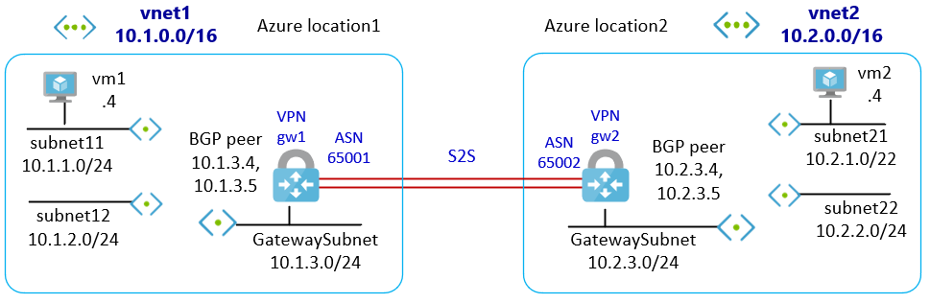

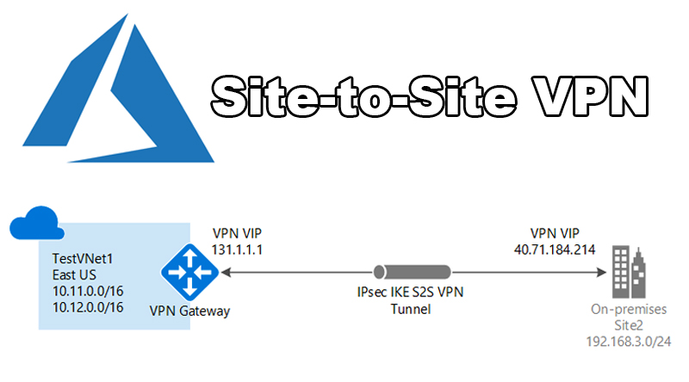

- Client-to-Site VPN (Point-to-Site)
- Connects individual user/device to cloud
- Example: Employee laptop → Cloud
- Requires VPN client software
- It is also over the internet but used for work from home system
- Once disconnected can not login again until vpn connected
- On demand connection : used when ever needed

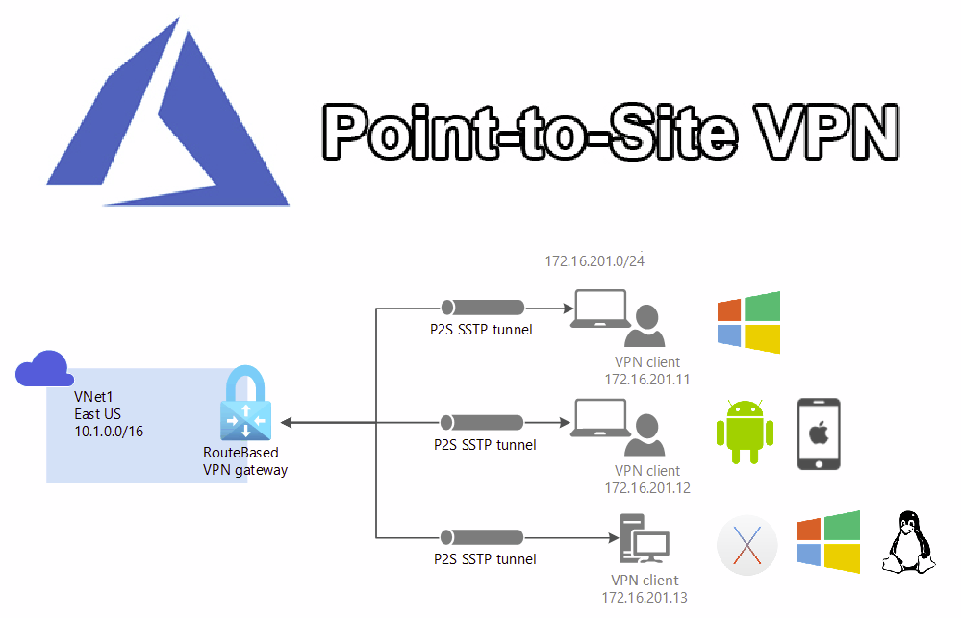

- Azure Express Route is a service from Microsoft that provides a private, dedicated connection between your on-premises network (data center, office) and Microsoft Azure.
- It does NOT use the public internet
- Connection is through a private network via a connectivity provider
- Offers high speed, low latency, and high security
- It is used for physical connection
- Here companies use partners network
- Ex : BSNL, Airtel, Jio Companies given lease their infra

- SSL – Secure Sockets Layer VPN – Virtual Private Network
- Uses SSL/TLS encryption (HTTPS)
- Accessible via browser or lightweight client
- Easy to use, no heavy setup

- IPsec VPN - Internet Protocol Security Virtual Private Network
- Uses IPsec protocol for strong encryption
- Most common in site-to-site VPN
- Works at network layer

- Uses of VPN in Cloud
- Securely access cloud servers (EC2, VMs)
- Connect on-premises data center to cloud
- Enable remote work securely
- Protect sensitive data from unauthorized access
- Access private cloud resources without exposing them to public internet

- Importance of VPN
- 🔐 Security – Encrypts data and prevents hacking/sniffing
- 🌐 Privacy – Hides internal network traffic
- 🔗 Hybrid Cloud Enablement – Connects on-prem + cloud seamlessly
- 👨‍💻 Remote Access – Employees can securely work from anywhere
- 💰 Cost Effective – No need for dedicated private lines (like MPLS)
- ⚙️ Scalability – Easily expand as cloud grows

- Hub and Spoke Architecture (VPN Concept)
- Hub-and-Spoke architecture is a network design where:
- A central Hub network manages shared services
- Multiple Spoke networks connect to the hub

- Centralized VPN (Shared Resource)
- VPN is created only in the Hub, not in every Spoke
- It acts as a shared resource for all connected Spoke networks
- This avoids duplication of VPN setups

- Resources in Hub Resource Group
- The Hub Resource Group contains common services like : VPN Gateway, Active Directory (AD), Firewall, Jump Servers (Bastion / access servers)
- These services are shared by all Spokes

- Cost Optimization
- Creating separate VPNs for each network is very expensive
- Approx cost: ~$120 per VPN (high cost if multiple VPNs)
- Using a single VPN in Hub significantly reduces overall cost

- Spoke Resource Groups
- Each Spoke Resource Group (RG):
- Contains application resources
- Uses private IP addresses only
- Does not expose resources directly to the internet

- Key Benefits
- Centralized security and management, Reduced cost, Better scalability, Improved network control

- Supported VPN Protocols : Azure VPN uses common secure protocols:
- IPsec/IKE
- OpenVPN
- SSTP (mainly Windows)
- These ensure the tunnel cannot be intercepted.

- Security Features : Azure VPN provides:
- AES 256-bit encryption
- IPsec/IKE security protocols
- Certificate authentication
- RADIUS and Azure AD authentication (for users)
- High availability with Active/Active gateways
- Monitoring & logging through Azure Monitor and Network Watcher

- Summary (Very Simple)
Feature | Meaning
Azure VPN | Secure connection to Azure
Protects data | Everything is encrypted
Works for offices and individuals | Site-to-Site + Point-to-Site
Easy to scale | Supports many users and high bandwidth

- AZURE ACTIVE DIRECTORY
- Azure Active Directory (Azure AD) is Microsoft’s cloud-based identity and access management service.
- Azure AD answers these questions
  - Who are you? (Identity)
  - What are you allowed to access? (Authorization)
- It is like a digital security guard for Microsoft cloud services.

- Simple Understanding
Office Item | Azure AD Equivalent
Employee ID card | Azure AD user account
Security gate | Azure AD
Office rooms | Applications / resources
Security guard | Azure AD policies
Visitor badge | Guest user

- Azure AD decides:
- Who can enter the building
- Which rooms they can enter
- When and how they can enter

- What Azure AD is USED for : Azure AD is used to:
- Log in to Microsoft 365 (Outlook, Teams, OneDrive)
- Log in to Azure portal
- Control access to Azure resources
- Provide Single Sign-On (SSO)
- Secure applications with Multi-Factor Authentication (MFA)

- Core Components of Azure AD (Very Simple)
    - Users : A user is a person.
- Examples: Employee: john@company.com
  - Admin: admin@company.com
  - Guest: vendor@gmail.com

- User can: Log in, Access apps, Be assigned roles

      - Groups : A group is a collection of users.
- Example: HR-Team, IT-Admins, Developers.
- Instead of giving permissions to each user: Give permissions to a group

- Applications : Apps that use Azure AD for login.
- Azure AD provides SSO: Login once → access many apps
- Examples: Microsoft 365, Azure Portal, Salesforce, Custom web apps

- Roles (RBAC) : Roles define what actions are allowed.
- Azure AD Roles (Identity level) : Global Administrator, User Administrator, Security Reader,
- Azure RBAC (Resource level) : Owner, Contributor, Reader
- Example:
- Global Admin → control Azure AD
- Contributor → manage Azure resources
- Reader → view only

- Authentication (Login Process) : This is how Azure AD verifies who you are.
- Common Methods:
- Username + Password
- MFA (OTP, Authenticator App)
- Biometric (fingerprint, face)

- Authorization (Permission Check) : After login, Azure AD checks:
- Are you in the right group?
- Do you have the right role?
  - If yes → access granted
  - If no → access denied

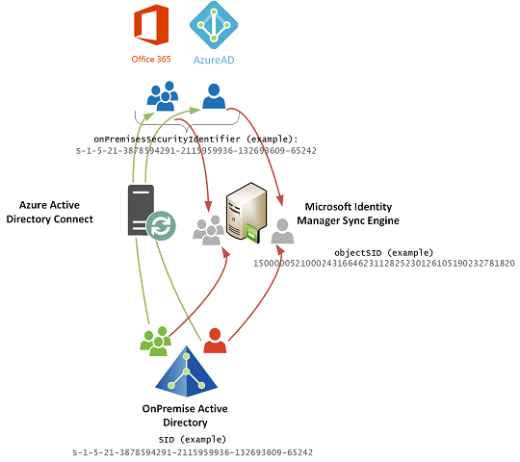
- Multi-Factor Authentication (MFA)
- MFA = Something you know + Something you have
- Example: Password (you know), Phone OTP (you have)
- This protects against: Password theft, Phishing attacks

- Conditional Access (Very Important)
- Conditional Access = rules that control access
- Example rules:
- Require MFA if login is from outside office
- Block login from risky countries
- Allow access only from company devices
- Think of it as smart security rules

- Azure AD Tenant : A tenant is a dedicated Azure AD instance for your organization.
- Tenant contains : Users, Groups, Apps, Policies
- Example : company.onmicrosoft.com

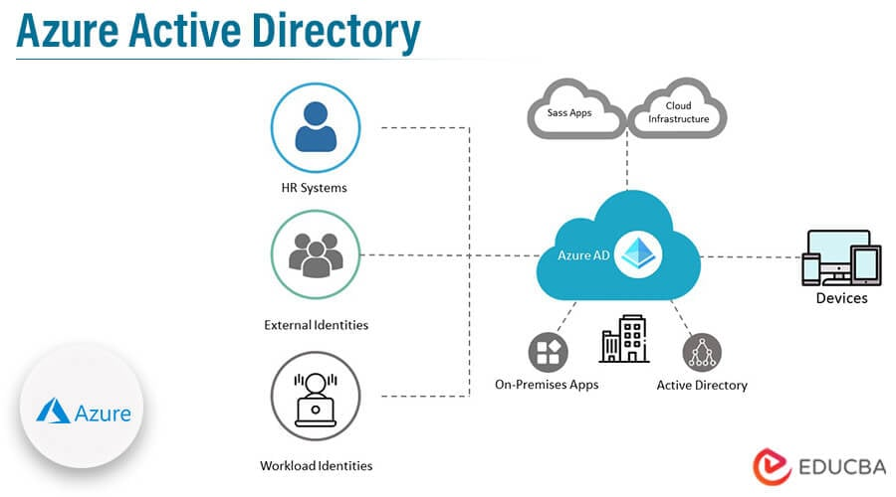

- Azure AD vs On-Prem Active Directory (Simple Comparison)
Feature | On-Prem AD | Azure AD
Location | Company servers | Microsoft cloud
Login | Domain join | Cloud login
Use case | Internal network | Internet + cloud
Protocols | LDAP, Kerberos | OAuth, SAML
Devices | Windows PCs | PCs, mobiles
They can work together using Azure AD Connect

- Azure AD Connect (Hybrid Setup) :
- Used when company has:
  - On-prem AD
  - Azure AD
- It syncs users from on-prem AD to Azure AD.
- User: One username, Same password, Access both cloud and local apps

- Azure AD Security Features : MFA, Conditional Access, Identity Protection
- Privileged Identity Management (PIM), Access Reviews

- Common Use Cases : Employees login to Office 365, Admins access Azure Portal
- Secure web applications, External users (B2B), Mobile device login

- Simple Login Flow (Step by Step)
- User opens app (Outlook / Azure Portal)
- App redirects to Azure AD
- User enters username + password
- Azure AD checks policies (MFA, location)
- Access token is issued
- App allows access

- Azure Active Directory is a cloud service that manages users, logins, and access to applications and Azure resources securely.

- AZURE MONITORING
- Azure Monitoring is a set of Azure services that collect, analyze, and alert you about what is happening in your Azure resources.

- Azure Monitoring = “See health, performance, and problems in Azure”

    - Think of Azure Monitoring like medical devices in a hospital:
Hospital Device | Azure Monitoring
Heart rate monitor | CPU usage
Blood pressure | Memory
Alarm if patient critical | Alert if VM down
Medical reports | Logs & metrics
- Azure Monitoring keeps your systems healthy and running.

- Azure Monitoring is Needed : Azure Monitoring helps you:
- Detect problems early
- Improve performance
- Reduce downtime
- Understand usage
- Get alerts before users complain

- Main Parts of Azure Monitoring :
- Azure Monitoring has 3 main pillars : Metrics → Logs → Alerts

    - Metrics (Numbers & Performance) : Metrics are numeric values collected automatically.
- Key points:
  - Collected every few seconds/minutes
  - Lightweight and fast
  - Used for real-time monitoring
- Example : “CPU is above 80%”

    - Logs (Detailed Records) : Logs are detailed text records of events.
- Logs are stored in Log Analytics Workspace.
- Examples : Who logged in,
  - Error messages,
  - Application failures,
  - Security events
- Example: “VM restarted at 10:32 AM by admin”

- Alerts (Notifications) : Alerts notify you when something goes wrong.
- Examples: CPU > 80% for 5 minutes, VM is stopped, App returns errors
- Alerts can send: Email, SMS, Teams message, Webhook

- Key Azure Monitoring Services (Very Important)
    - Azure Monitor (Main Service) : The central service for monitoring everything.
- It: Collects metrics, Collects logs, Sends alerts, Shows dashboards

      - Log Analytics
- Used to: Store logs, Search logs using KQL (query language)
- Simple KQL example:
SecurityEvent
| where Level == "Error"

- Application Insights : Used for applications.
- Monitors: App performance, Response time, Errors, User behavior
- Best for web apps & APIs.

- Azure Alerts : Creates alerts based on:
- Metrics, Logs, Activity

- Azure Dashboards & Workbooks : Used to visualize monitoring data.
- Charts, Tables, Graphs

- What Can Be Monitored?
Resource | What is Monitored
Virtual Machines | CPU, memory, disk
Web Apps | Requests, errors
Databases | Queries, latency
Network | Traffic, failures
Security | Login attempts
Storage | Capacity, access

- Monitoring a Virtual Machine (Example)
- Step-by-step:
- Azure Monitor collects CPU, memory, disk metrics
- Logs stored in Log Analytics
- Alert rule checks CPU usage
- If CPU > 80% → alert sent
- Admin takes action

- Activity Logs (Important)
- Activity Log tracks : Who did what, When changes happened
- Used for : Auditing, Security, Troubleshooting
- Example: “User X deleted VM Y”

- Difference Between Metrics and Logs (Very Simple)
Metrics | Logs
Numbers | Text
Fast | Detailed
Short retention | Long retention
Real-time | Historical analysis

- Azure Monitoring Architecture (Simple)
Azure Resource
↓
Metrics & Logs
↓
Azure Monitor
↓
Alerts / Dashboards

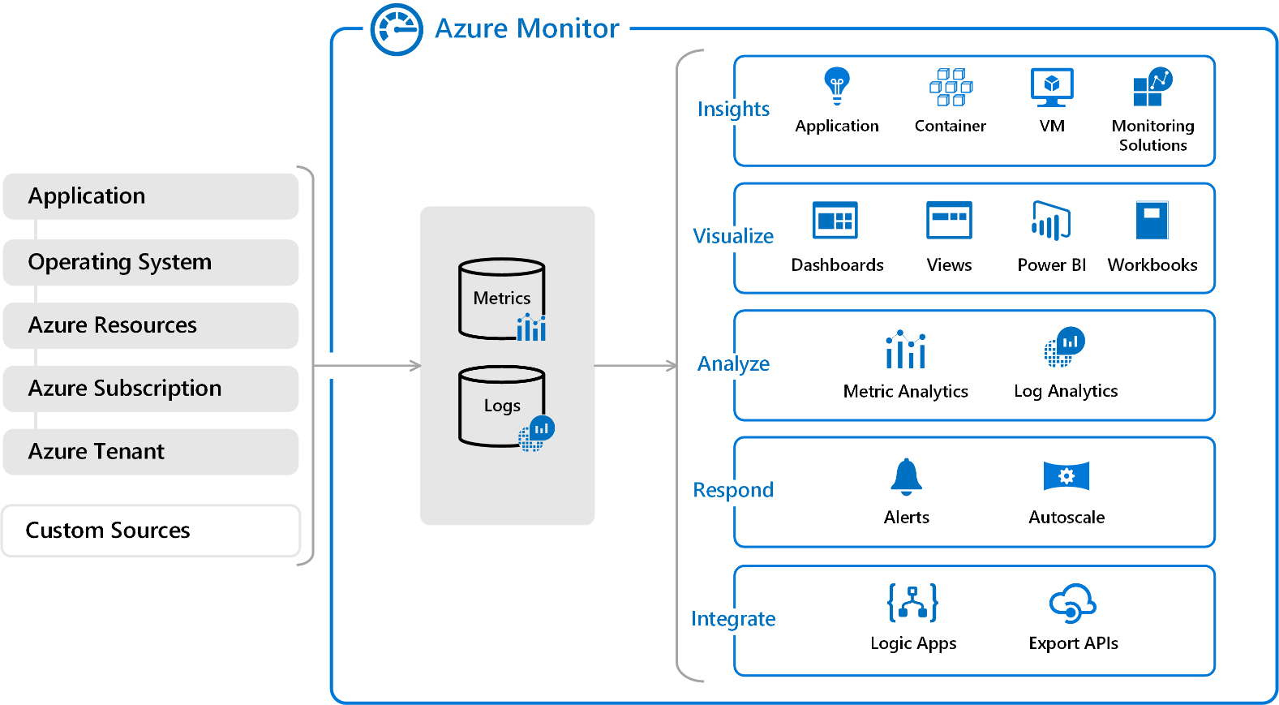

- Security in Azure Monitoring : Role-based access (RBAC)
- Encrypted data
- Audit logs
- Compliance ready

- Pricing (Simple)
- You pay for:
- Log data ingestion
- Data retention
- Alerts
- Metrics are mostly free
- Logs cost depends on GB collected

- Common Use Cases
- Detect VM crashes
- Monitor app performance
- Security auditing
- Capacity planning
- Troubleshooting issues
- SLA monitoring

- Azure Monitoring helps you track performance, detect problems, and receive alerts for your Azure resources.

- AZURE LOGIC APPS
Azure Logic Apps is a cloud service that automates tasks and workflows without writing much code.
- Logic Apps = If this happens → then do that automatically

    - Azure Logic Apps is Used :
- Logic Apps helps you : Automate repetitive tasks
  - Connect different services together
  - Integrate systems without coding
  - Reduce manual work

- Common users : IT admins
  - DevOps engineers
  - Business users

- Key Concepts (Very Simple)
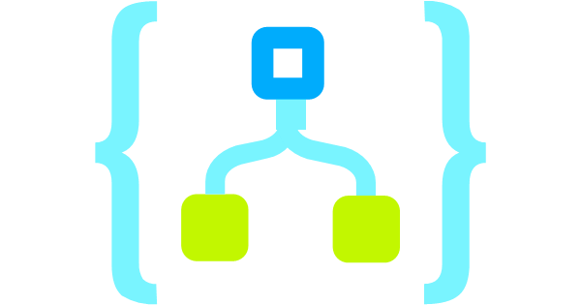
          - Workflow : A workflow is the automation you build.
- Example: Receive email → Process data → Send notification

- Trigger : A trigger starts the workflow.
- No trigger = workflow will not run

- Examples:
- When an email arrives
- When a file is uploaded
- On a schedule (every day at 9 AM)
- When an HTTP request is received.

    - Actions : Actions are the steps performed after the trigger.
- Examples : Send email
- Create file
- Insert row in database
- Call an API

    - Connectors : Connectors are pre-built integrations with services.
- Connectors save you from writing code.

- Popular Connectors: Outlook, Teams, SharePoint, OneDrive, SQL Server, Azure Blob Storage, Salesforce

- Simple Workflow Example : When a file is uploaded to Blob Storage → send email alert
- Steps:
- Trigger: File created in Blob Storage
- Action: Send email via Outlook
- Action: Post message to Teams

- Types of Triggers
Trigger Type | Example
Event-based | Email received
Schedule | Every hour
HTTP | API call
Manual | Button click

- Conditions (Decision Making) : Logic Apps can make decisions.
- Example:
If amount > 10,000
Send approval email
Else
Auto approve

- Loops (Repeating Actions) : For each loop:
- Used when working with lists.
- Example:
- Process each email attachment
- Loop through rows in Excel

- Azure Logic Apps vs Azure Functions (Simple)
Logic Apps | Azure Functions
Low / no code | Code required
Visual designer | Code editor
Easy integration | Custom logic
Business workflows | Developer workflows

- Logic Apps = integration
- Functions = coding logic

- Pricing (Simple) :
- You pay for: Number of triggers, Number of actions executed
- No cost when workflow is idle.
- Example: 1 trigger + 3 actions = 4 executions

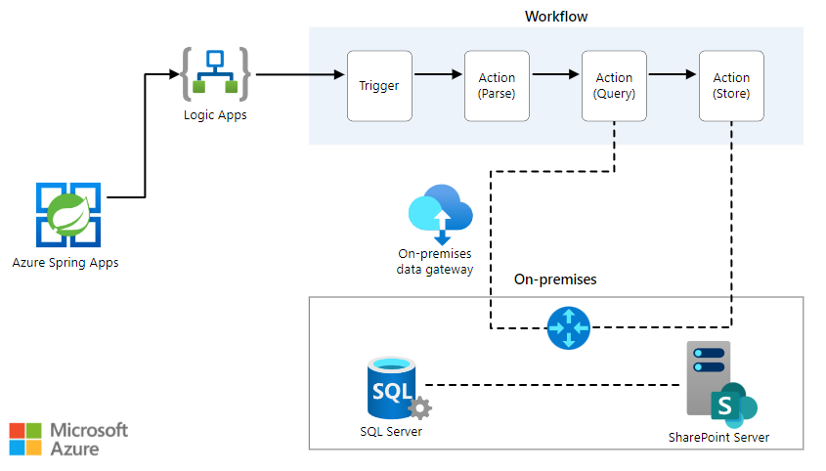

- Security in Logic Apps
- Uses Azure AD authentication
- Secure API connections
- Role-based access
- Data encryption

- Common Use Cases : Email automation, File processing, Approval workflows, Data sync between systems, Monitoring alerts, API integration

- Logic Apps Workflow Execution (Step-by-Step) : Trigger fires, Workflow starts, Actions execute in order, Conditions checked, Loop if needed, Workflow completes

- Visual Designer (Why People Like It) : Drag and drop, Easy to read, Easy to modify, Built-in error handling

- Error Handling (Simple) : Retry policies, Run after failure, Alerts on failure

Azure Logic Apps is a cloud service that automates workflows by connecting apps and services using triggers and actions, with little or no coding.
